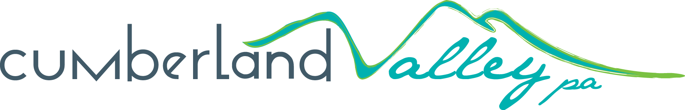
2017 Seasonal Application
Program (SNAP) Application
Sponsored by the Cumberland Valley Visitors Bureau

Applications will be accepted January 17, 2017 through September 15, 2017.
Handwritten applications will not be accepted.

Section One: Overview
Organization Name:
Non-Profit (yes/no)? Tax EIN:
Street Address:
City/State/Zip:
Contact Name & Title:
Contact Phone & E-mail:
SNAP Request: $
Please check the appropriate category (ies):

Printing of Experiential Brochures

Media Development

Advertising for Major Events

Signage
Section Two: Project Details

- What are the deliverables of this project? (The number of brochures printed, signs placed, photos taken, videos created, or number of ads placed and impressions served.)

- What is the desired outcome of your project? For example, where will you distribute your brochures, where will signs be placed, how many people will come to your establishment from your ad, how you will use new photos, etc.

Section Three: Application Checklist

- Attach the following items to your completed application:

- Copy of finished design (for brochures, advertising and signs)
- Quote(s) from your selected vendor
- Letter of Support from landowner giving permission to place sign (signs only)

- Submit a digital copy of this application with attachments to:

Cumberland Valley Visitors Bureau (CVVB)
Attn: Ashley Kurtz, Promotions Manager
akurtz@visitcumberlandvalley.com

- Please also call Ashley to confirm receipt of your application:

Ashley Kurtz, Promotions Manager
(717) 240-7192

I/We affirm that all information in this application and all attachments are true and correct to the best of my/our ability, and that the receipt of any funds relative to this request will be used for the purpose detailed within this application. I/We agree to abide by all local, state and federal regulation as they apply. I/We understand that the Tourism Grant Review Committee may request additional information and/or personal interview from applicants.

Name: Title:

Signature: Date:

