CRM Instructions
Updating Contacts

http://extranet.denver.simpleviewcrm.com

Viewing Your Member Record
Depending on your access levels, there are various items that can be viewed under your Member Record:
- Contacts

Contacts:
1. To update your contact records, edit the current contact by clicking “Edit” (pencil icon) to the left of the contact.

2. To add a new Contact, click the “New Contact” button.

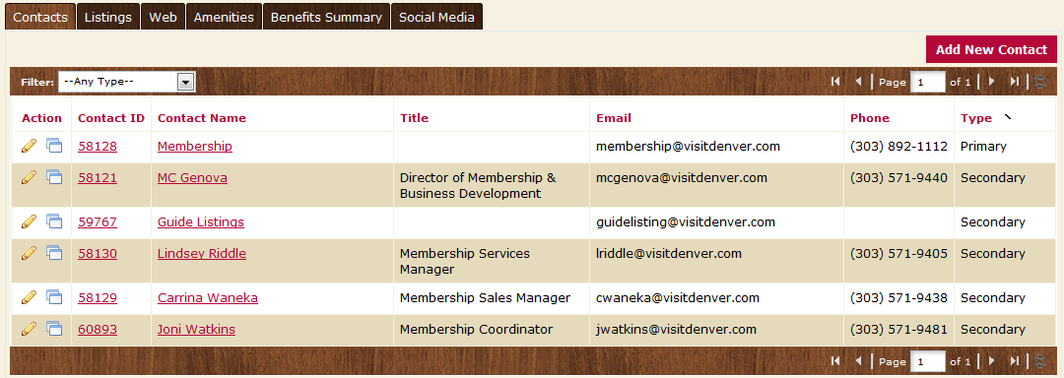

Please note: If a staff member leaves and a new one arrives, please make the old contact inactive and create a new contact record for the new person. You can do this by changing the “Contact Type” to Inactive.

