CRM Instructions
Responding to Sales and Viewing Tourism Leads

http://extranet.denver.simpleviewcrm.com

Reviewing Sales Leads:
- Once you are logged in, click on the “Leads” tab in the upper left hand corner of your screen.
- By default, only leads in which you can still respond to are displayed. You can use the filters to view leads by the following:
  - Status
    - New – lead is not lost or definite and the response date has not yet passed
    - Pending – lead is not lost or definite but the response date has passed
    - Closed/Won – leads turned definite where your property was chosen
    - Closed/Lost – leads turned definite where your property was not chosen OR the lead was turned to lost business
    - Closed/TBD - leads turned definite but the client has not chosen a hotel
  - Groups (Meeting, Tour, or Media)
  - Whether you have responded or not
  - Search for leads by Organization or Lead or Lead ID. Once your search term is entered, press tab on the keyboard and the results will be filtered
- You are able to sort your list of leads by clicking on any of the column headers (i.e. Meeting Name, Organization, etc)
- If you select “New” under the “Status” drop-down, it will show only the leads that you have not yet responded to

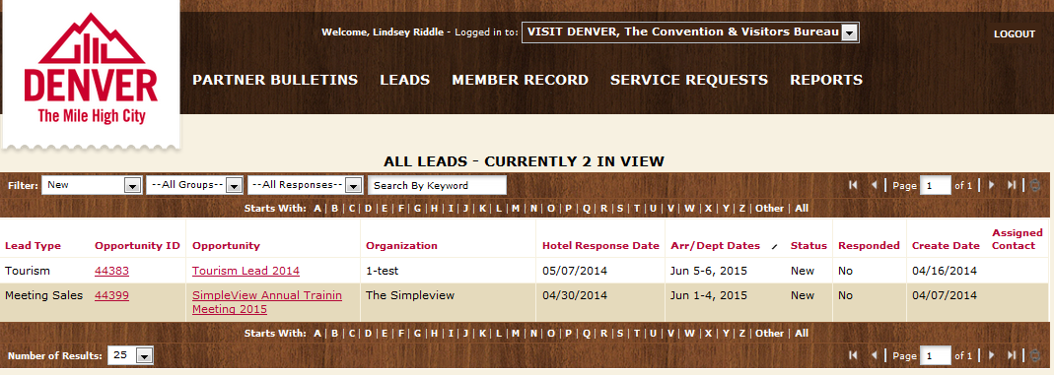

Assigning Leads:
As a Lead Catcher, you will be responsible for assigning a lead to your Sales Managers. To assign a specific lead, click on the Opportunity ID or Opportunity Name to get to the detail screen.

- In the detail screen, scroll to the Contact section
- Click Change Contact

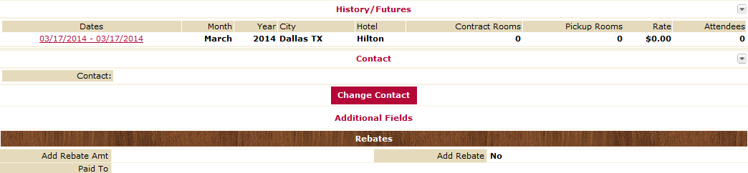

- In the dropdown, select the Sales Manager that you would like to assign the lead to
- Click Save. This will generate an email to the Sales Manager letting them know they have a lead assigned to them.
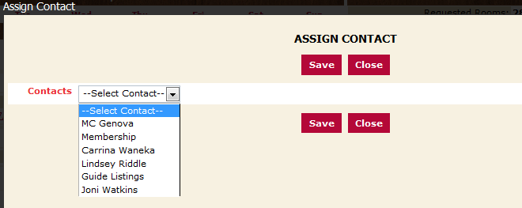

Viewing & Responding to Leads:
- Click on the Lead ID or Title to open and respond.
- Please note that the Hotel Response Date listed is your deadline to respond. Once this date has passed, you will no longer be able to respond to the lead online (or edit your response).
- If a client response is required, click on the client’s email address to send your response directly to the client (respond to the CVB online in addition to this response)
- If the lead has an attached RFP, it will be located in a field titled “Meeting Specs”. Simply click the file name to open/download it.

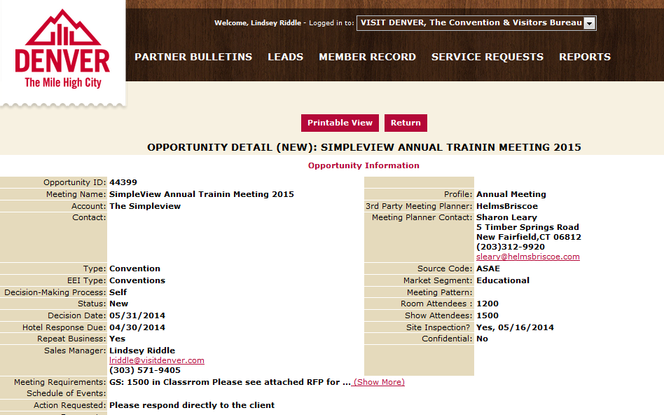

- In the bottom left corner you will see an “Add Your Response” or “Edit Your Response” link – click the link to open and respond to this lead

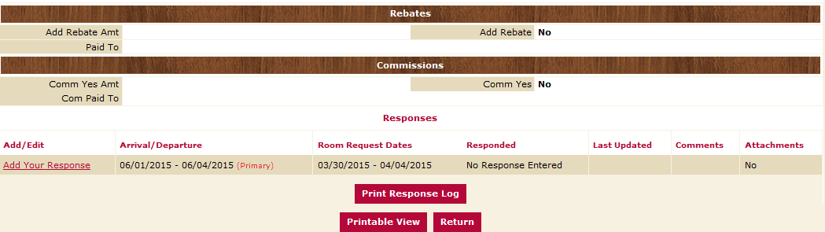

- Fill in the appropriate information, and click “Save” at the bottom
- Note that items in red are required fields
- Bureau Only Comments will only be seen by VISIT DENVER (the client will not see them)
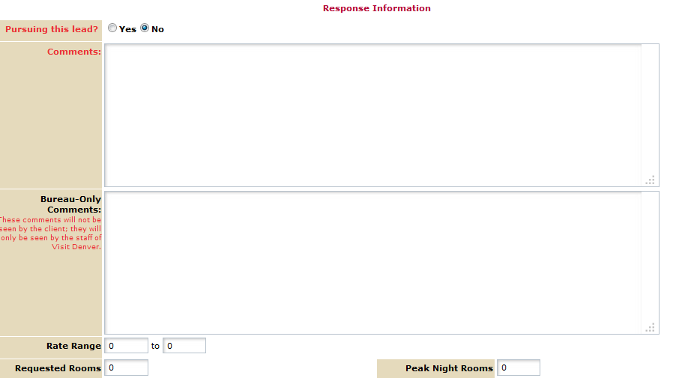

- Once you click Save, an email is generated and sent to the Sales Manager at VISIT DENVER notifying them know that you have entered your response.
Entering Pickup
- Once a meeting has been turned into Definite business, you will see a “Pickup” section at the bottom of the screen beneath the response.
- After the meeting has taken place, you can enter the number of rooms you received from this meeting.
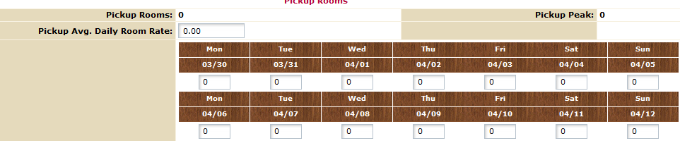

Responding to Tour Leads
- On the Leads grid, use the filters to view Tour Leads.

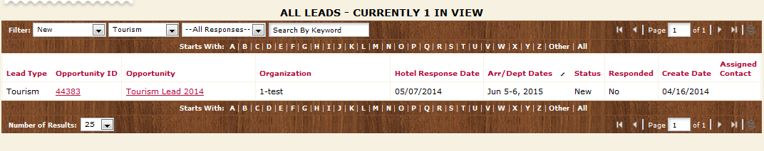
- Click on the Opportunity ID or Title to open and respond.
- If needed, assign the lead to a specific Sales manager by clicking on “Change Contact.

