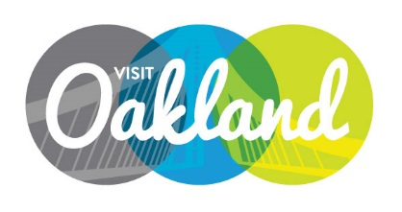

Board of DiRECTORS Meeting Agenda
Tuesday, January 11, 2016 4 pm – 6 pm
Location: Executive Inn & Suites, 1755 Embarcadero, Oakland, CA 9460
Michael LeBlanc, Chair, Presiding

- Call to Order M. LeBlanc

- Public Comment / Announcements
- Guest Speakers
Zach Wasserman, Brown Act Basics
- Approval of Minutes Motion
Board of Directors minutes December 1, 2015

- Financial Report M. Everton / M. Rose / Motion
Finance Committee Report/ Budget Review
Budget Process
Approval of November Financials
- Marketing Committee Report M. LeBlanc
ORW 2016
Super Bowl

- Nominating Committee Report M. Hochstatter
- Tourism Advocacy Committee Report S. Nassif

- CEO Report A. Best
Staff Reports
Strategic Plan

- Adjournment M. LeBlanc

NEXT MEETING: February 16th – 4 pm / Location: TBD

