2.5 Liquid Bulk Market (Petroleum Products)
2.5.1 Summary
Purvin & Gertz (P&G) was responsible for conducting the Petroleum Sector Strategy Study for Port Everglades in 2005. While the results were consistent with the outlook for petroleum products at the time, significant changes have occurred in the US and global markets since the study was originally conducted for Port Everglades. The increase in oil prices from 2004 through mid-2008 and the economic collapse in the second half of 2008 have contributed to a marked slowdown in product demand. For these reasons, the throughput and competitive aspects of the study have been updated in this section, taking the recent developments into account.
Overall, US light petroleum product demand will fall this year (2009) before recovering in 2010 and growing at an average rate of 0.6 percent per year through 2017 and then declining slowly through the end of the forecast period. The eastern US (PADD I) is forecast to follow a similar path as the US. Annual growth rates will recover in 2010 and increase at an average of 0.5 percent per year through 2017 before declining at an average of 0.5 percent annually.
Florida’s annual demand growth rate for light products is greater than that of every other state in PADD I, with the exception of Georgia. Florida’s light product annual demand growth is higher than that of the US and PADD, averaging 1.2 percent per year from 2010 through 2020 before slowing down to an annual growth rate of 0.1 percent through 2029. For the same period, the 12--county market served by Port Everglades will experience flat light product demand through 2010 before rebounding at a 1.3 percent annual average through 2019 and then seeing demand growth slow to 0.2 percent annually through 2029.
Of the seven major commercial ports in Florida, three currently have major petroleum terminaling capabilities: Port Everglades, the Port of Tampa and the Port of Jacksonville. A major expansion at Port Canaveral is due to be operational in late 2009 or early 2010. Of these ports, only the Port of Tampa and Port Canaveral are within reasonable trucking distances and, therefore, are considered competitors with Port Everglades.
Approximately 4.8 million barrels of new storage capacity will be available throughout Florida by 2010, with another possible 5.1 million barrels in the planning stages. Port Canaveral’s expansion will be a threat, directly and indirectly, to portions of Port Everglades’ 12-county market. Since very little light product has traditionally come through Canaveral, the expansion will likely overtake counties closest to the Port. In this case, Canaveral is anticipated to supply Indian River and St. Lucie counties after the expansion is complete while possibly displacing additional volumes from Tampa into other areas of the Port Everglades market. The expansion is expected to take over 44,000 barrels per day (B/D) in gasoline and diesel demand from Port Everglades as soon as 2010. The Port of Palm Beach completed a small expansion in 2007 that has taken away a small portion of the Port’s diesel market, but that amount is believed to be less than 4,000 barrels per day. The Port of Tampa is also undergoing an expansion at this time, but the additional tankage is expected to have little effect on the Port Everglades market area. Other terminal plans in Florida and the Caribbean are not expected to significantly affect Port Everglades’ throughput outlook.
Several refinery expansions are currently underway and planned along the US Gulf Coast. Several of the refinery owners are also terminal operators in Florida. While some of this new product volume may go to Florida, much of it is expected to be directed to the US East Coast market via pipeline due to the relatively lower pipeline shipping costs and lower delivered product cost from Europe into Florida relative to the Gulf Coast.
Figure 2.5-1 provides the Port Everglades petroleum throughput forecast summary. Total throughput volumes are expected to grow from just over a projected 300,000 B/D in 2008 to 323,000 B/D by 2029. Gasoline will continue to be the leading product; however, due to a more rapid diesel demand growth, the percentage of the throughput attributed to gasoline will fall over the forecast period from 53 percent of the total in 2008 to 42 percent by 2029.
Figure 2.5-1
Port Everglades PetroleumThroughput
(Thousand Barrels per Day)

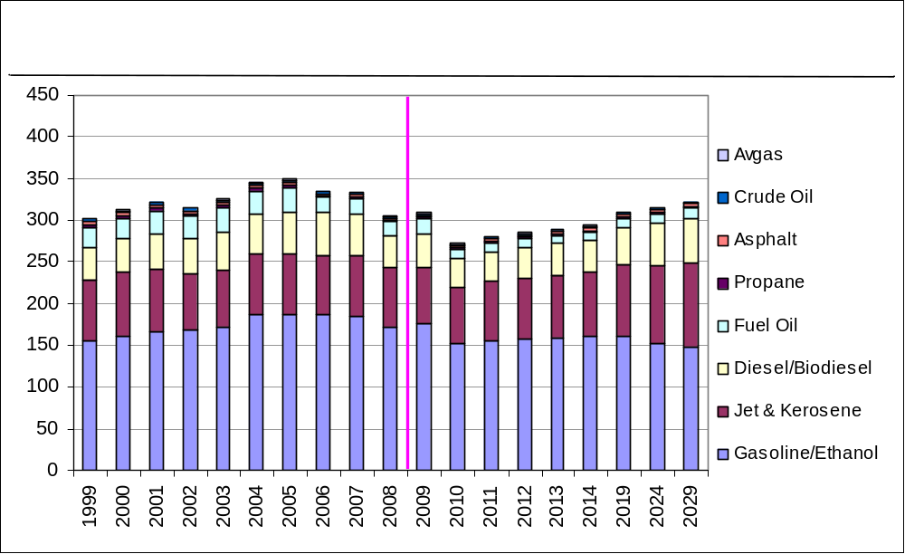

Figure 2.5-2 illustrates the projected number of annual vessel calls for the period from 1999 to 2029. The number of tanker calls will decline through 2010 before increasing at an annual average of 0.8 percent through 2020, then, despite rising throughput, flattening out through the forecast period due to the projected increase in the sizes of foreign vessel calling the Port. It is expected that the percentage of foreign tanker calls will decrease slightly through the forecast period, after a sharp increase between 1999 and 2008, due to larger vessels and the number of new Jones Act tankers currently planned or being manufactured.
Figure 2.5-2
Tanker Calls at Port Everglades
(Calls per Year)

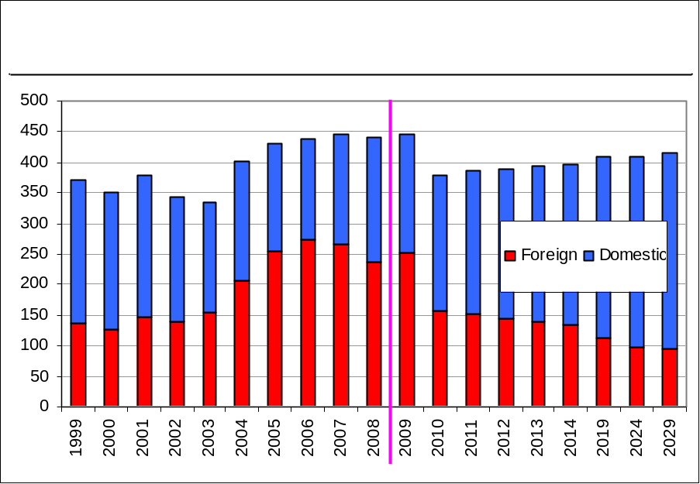

The expected number of barge calls, as shown in Figure 2.5-3, should return to 2008 levels by 2019. The increase in barge calls is primarily driven by the increasing petroleum product demand/throughput.
Figure 2.5-3
Barge Calls at Port Everglades
(Calls per Year)

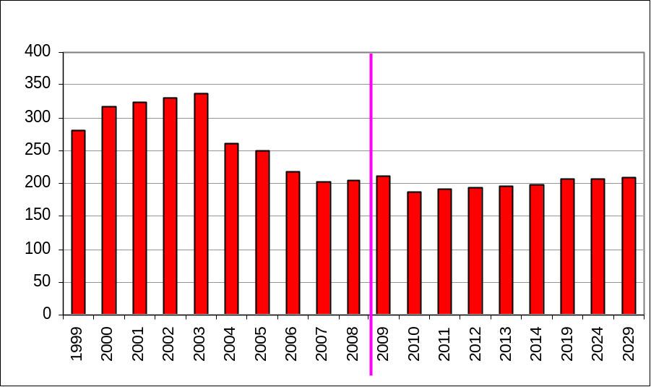

After Hurricane Katrina destroyed the Dynegy plant in Venice, Louisiana, in 2005, the volume of propane (LPG) available to them to bring into the Port decreased significantly. Much of their market share has since been taken by C-3, through the Port of Tampa, resulting in a dramatic decrease in barge calls in recent years. Demand is forecast to resume a growth trend in 2010 through the end of the forecast period, as shown in Figure 2.5-4.
Figure 2.5-4
LPG Barge Calls at Port Everglades
(Calls per Year)

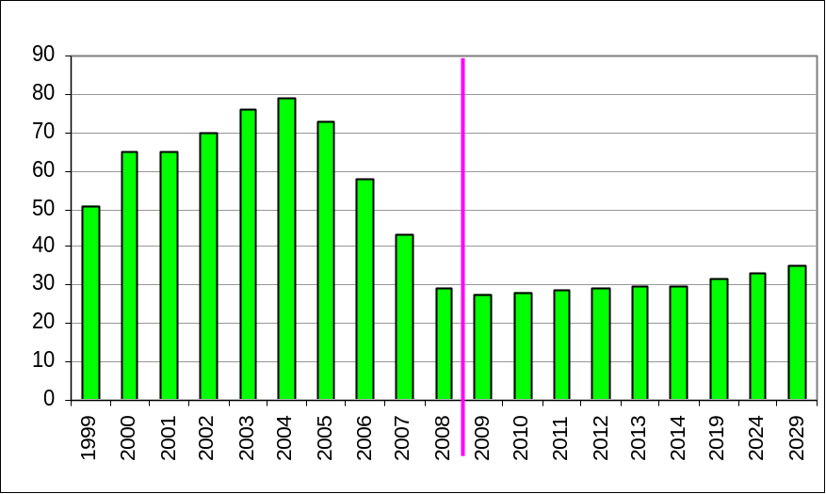

Despite the market demand downturn since the 2005 PGI report, several other factors must be considered when making decisions regarding the Port’s liquid bulk infrastructure.
- Deliveries to the Port are not ratable and annual average volumes may not reflect peak activity at the Port, masking actual facility limits.
- Reductions in demurrage costs may create a competitive advantage.
- Port Everglades now has an increased number of terminal operators and, therefore, ships calling on the Port.
- New fuels have created a complexity not considered in the 2005 report. Additional products such as biodiesel, ethanol, and several grades of gasoline and diesel may require additional dock piping, tankage, and calls on the Port.
- There is uncertainty in the planning basis, as forecasts are inherently uncertain.
2.5.2 Market Forecast
Forecast Methodology Overview. This section discusses Port Everglades’ liquid bulk market, specifically the diverse petroleum products that account for a substantial portion of the Port’s revenue. For the most part, the analytical basis for this section has been derived from P&G’s. Global Petroleum Market Outlook and data acquired from the Port. Additional specifics have been derived from the Consultant Team’s interviews with several of the Port’s petroleum industry tenants.
Total US Demand and Factors. Total demand for refined products in the US is influenced by many factors. The relative strength of the economy, petroleum prices, the regulatory environment, the extent of travel, the fuel efficiency of the fleet, and assumptions regarding alternative motor fuels all affect the outlook for petroleum fuels.
Economic activity is a strong driver of US petroleum demand. Demand for refined products grew at a rate of 0.7 percent per year from 2000 to 2007. This low growth rate can be attributed to a weak economy in 2001/2002, the increase in oil prices in 2004-2007, and a big decrease in fuel oil demand in 2006. In 2008, however, demand is estimated to have fallen by over 1.2 million B/D in response to high prices and the economic collapse in the second half of the year. Demand is expected to fall again in 2009 before resuming weak growth in 2010 through 2020. Past 2020, declining gasoline demand is expected to outweigh growth in other products.
Despite the sharp drop in 2008 and 2009, ultra low sulfur diesel is expected to show the greatest increase in the longer term, with a strong recovery after 2010. Jet fuel growth will be constrained due to more efficient airline fleets and possibly lower airline traffic. Gasoline demand will continue to decline over the next few years, with increasing supplies of ethanol displacing petroleum-based gasoline as a result of the Energy Independence and Security Act of 2007 (EISA). Longer term, total gasoline demand (including blended ethanol) will recover through about 2016, but demand will then start to decline as more efficient new vehicles mandated by EISA start to impact the fuel economy of the overall fleet.
The EISA requires a gradual increase in new light duty vehicle fuel efficiency, up to 35 miles per gallon (MPG) on average by the 2020 model year. This is a very significant change from the previous requirements of 27.5 MPG for cars and 22.5 MPG for light trucks. The impacts of this efficiency improvement will not begin to be seen in the overall fleet until at least 2015, since the new requirements start to take effect in the 2011 model year.
The Consultant Team’s analysis still indicates that alternative fuels are not likely to have a significant effect on gasoline demand until after 2020. The extent of the impact is by no means a clear issue at this point. The primary alternative fuels presently at issue include methanol, compressed natural gas (CNG), LPG, electricity, and hydrogen. LPG (primarily propane) has contributed 30,000 to 40,000 B/D to the transportation sector, and this is projected to grow to about 55,000 B/D during this decade. Though CNG is currently in use, its application is likely to be restricted to fleet vehicles for some time. Fleet vehicles, however, represent only a small portion of the overall fleet, and the effect on gasoline demand, therefore, would likely be small, unless full conversions were made. A major portion of CNG use is also displacing diesel fuel rather than gasoline. Methanol usage is also expected to be inconsequential, taking into account such factors as toxicity, logistics, and economics. Ethanol use at 85 percent blend (E85) would displace an equivalent volume of gasoline supplied, lowering the equivalent total fuel requirement.
Market Allocation by PADD. Annual PADD-level consumption for each refined product is based on historical Department of Energy (DOE) data. The PADD consumption is divided by the total population of the PADD, producing a demand-per-capita value for each year. This demand is then allocated to each state based on the number of people in the state that are of driving age. The state demand can then be compared with the State Energy Data System (SEDS) data published by the Energy Information Administration (EIA) for the state and normalized.
State and County Distribution. State historical consumption estimates for gasoline, diesel, and kerosene (excluding jet fuel) are based on the SEDS data. The SEDS basis was used as the PADD-to-state allocation for the Florida jet fuel demand. For all other states, the overall PADD-level demand, as reported by the DOE, was distributed to the state-level, based on the FAA’s Airport Operations summaries for each state. Florida county demand was then determined using the FAA’s Airport Operations summaries by allocating the total state jet fuel demand to each county by percentage of total state flights, by county.
The state petroleum consumption forecast is made based on an independent forecast of state population and the PADD-level demand forecast. The historical per-capita state consumptions are grown at the PADD-level per-capita consumption growth rate. Multiplying the per-capita consumption estimate by the forecast population results in a first-pass forecast of state consumption. Due to uneven population growth, the first-pass sum of the state forecast demand does not exactly match the PADD-level forecast. Therefore, an iterative technique is used to adjust each of the state demand estimates based on an error distribution between the sum of the state demand and the forecast PADD demand.
Population Drives Light Product Demand. Population growth is a large determinant in the forecast of gasoline and transportation diesel and, to a lesser extent, heating oil and jet fuel. As the population grows, the demand for light petroleum products will increase. The population history and forecast basis used for this analysis is from the Florida Bureau of Economic and Business Research 2007 projections. The population statistics are provided at the state and county level, which facilitates the state sub-regional demand analysis.
Historically, Florida’s population growth has been robust. Between 2000 and 2008, the population in Florida grew an average of 2.1 percent per year. From 2009 to 2029, growth in Florida is expected to slow as a result of economic conditions to an annual average of nearly 1.9 percent per year. This is stronger than the expected average growth for the entire US over this period, which is 0.9 percent per year.
At these growth rates, Florida will overtake New York as the most populous state in PADD I by 2010 (see Table 2.5-1). Florida, now the fourth most populous state, will also edge past New York into third place in total population by 2011. California and Texas will remain the top two most populous states. Recent projections out to 2029 indicate that Florida, California, and Texas will each gain more than 6.5 million residents and together will account for more than 40 percent of the nation’s growth.

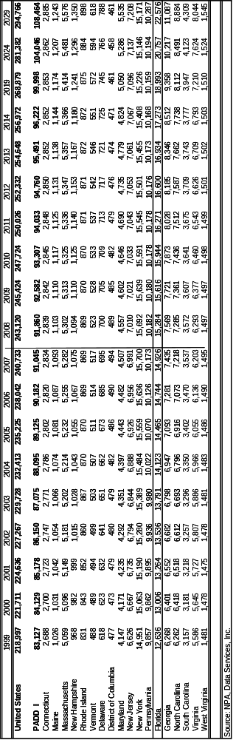
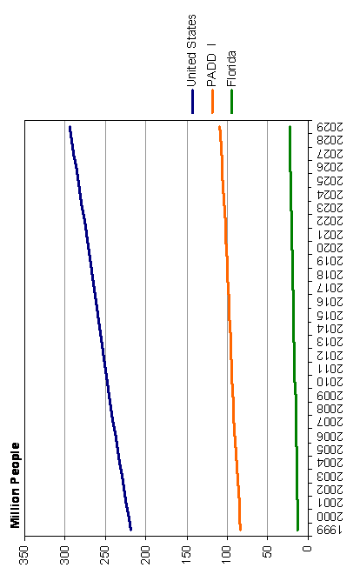
Table 2.5-1
State and PADD Population Trends
(Thousands of People)
2.5.3 Petroleum Demand Forecast
The dramatic increase in crude oil and gasoline prices in the first half of 2008 led to an equally dramatic demand response. The economic meltdown that began in late summer contributed to further weakness. As a result, US total petroleum demand declined by 1,262,000 B/D in 2008 of which gasoline fell by nearly 325,000 B/D. A smaller decline in total petroleum demand is projected for 2009, after which a very modest recovery is expected to begin in 2010.
Gasoline demand growth is expected to average about 0.2 percent per year from 2010 through 2015. After 2015, a plateau is expected and then a gentle decline in demand as the effects of increasing fleet efficiency begin to be seen.
Gasoline demand in the US remains significantly higher than gasoline supply resulting in gasoline imports of over 700,000 B/D in 2008. In addition, another 300,000 B/D of gasoline blendstocks were imported. Primary sources are Europe, Canada, and the Caribbean. Imports are expected to fall as new US refinery capacity comes on line in the 2010-to-2014 time frame.
Diesel consumption has not been subject to the trends in vehicle efficiency that have influenced gasoline demand, but are much more closely tied to economic activity and weather changes. The bulk of diesel fuel demand is used in commercial transportation, which moves directly with strength in the economy. Demand for distillate fuel oil in the residential/commercial sectors moves with short-term temperature trends and has been subject to long-term encroachment by natural gas.
Distillate demand grew at an average rate of 2.2 percent from 2002 to 2007. Demand growth for this product tracks GDP growth closely. Demand fell by over 6 percent in 2008 with the economic downturn, and growth is not expected to return until 2010. Annual average growth rates through the next five years are expected to average 0.4 percent.
Changes in the sulfur level of the distillate pool have come from both shifting demand patterns and regulatory mandates. Faster growth in diesel demand relative to thermal consumption of distillate (residential, commercial, utility, etc.) has resulted in a growing demand share of the 500 parts per million (ppm) on-highway product. Regulations that became effective in June 2006 require 80 percent of on-highway supply to meet the 15-ppm sulfur specification, moving to 100 percent in 2010. Off-road diesel sulfur limits were tightened to 500 ppm in 2007 and will be further tightened to 15 ppm in 2010. These factors will result in the high sulfur demand share falling with the 15-ppm product growing rapidly through 2015.
Most of the distillate fuel oil consumed in the US is produced domestically, but imports have been increasing in recent years. This material is primarily imported from the Caribbean to the East Coast, but Canada is also a major supplier. Exports have also increased in recent years, primarily to destinations in Latin America. Due to the more robust growth of distillate demand relative to gasoline, refinery production of distillate relative to gasoline will continue to increase.
Other trends in the petroleum forecast are as follows:
- Air travel and, therefore, jet fuel demand, have yet to fully recover from the September 11th attacks and it is expected that they will remain depressed for some years to come. Growth is expected to resume after the current recession as airline travel grows. Offsetting increased travel is a continuing trend of more efficient passenger jets replacing less efficient aircraft models.
- The sulfur content of residual fuel oil, specifically bunker fuels, is being reduced. Residual fuel oil consumption is expected to decline slowly as natural gas continues to displace its use for electricity generation.
The long-term declines in utility demand and a small amount of industrial demand result in the transportation sector becoming the dominant demand sector for residual fuel oil. The Consultant Team’s forecast anticipates that residual bunker demand will erode slowly in the long term with the growing use of gasoil bunkers as a result of new MARPOL regulations. Longer term, these trends result in declining residual fuel oil demand.
US Overview. The dramatic increase in crude oil and gasoline prices in the first half of 2008 led to a dramatic demand response. The economic meltdown that began in late summer contributed to further weakness. As a result, gasoline demand is estimated to have declined by roughly 325,000 B/D in 2008. A smaller decline is projected for 2009, with a very modest recovery beginning in 2010. Gasoline demand growth is expected to average about 0.2 percent per year from 2010 through 2015. After 2015, a plateau is expected, followed by a gentle decline in demand, as the effects of increasing fleet efficiency begin to be seen.
Demand growth for distillate tracks economic activity (GDP growth) closely. Demand fell by over 6 percent in 2008 with the economic downturn, and growth is not expected to return until 2010. Annual average growth rates through the next five years are expected to average 0.4 percent.
Total demand for aviation fuels in aggregate is expected to fall in 2009. Growth is expected to resume in 2010 at an average rate of 1.2 percent per year through 2029.
Residual fuel oil demand should continue to decline at an average of 0.2 percent annually over the forecast period, being displaced by natural gas.
Due to the projected recovery in demand growth and the impact of several large expansions, crude oil runs are projected to increase from 14.6 million B/D in 2008 to 16 million B/D by 2015. After 2015, demand for petroleum gasoline starts to decline and this is expected to pressure the refining system to reduce marginal crude runs.
PADD, Florida, and Port Everglades Forecasts. The US light product demand will fall some this year (2009), before recovering in 2010, growing at an average rate of just over 0.5 percent through 2014, and then declining slowly through the end of the forecast period. PADD I is forecast to follow a similar path to that of the US. Annual growth rates will recover in 2010 and increase at an average of 0.6 percent per year through 2019 before declining at an average of 0.4 percent annually through 2029.
Florida’s annual demand growth rate for light products is greater than that of any other state in PADD I, except Georgia. During the forecast period, shown in Table 2.5-2, Florida’s light product annual demand growth is expected to be higher than that of the US and the PADD average rate of 1.2 percent between 2010 and 2019 before slowing down to an annual growth rate of 0.1 percent through 2029. For the same period, the 12-county market served by Port Everglades and shown in Figure 2.5-5 will experience flat light product demand through 2010 before rebounding at a 1.3 percent annual average through 2019 and then seeing demand growth slow to 0.2 percent annually through 2029.
Table 2.5-2
United States Light Product Demand
(Annual Growth Rate, %)

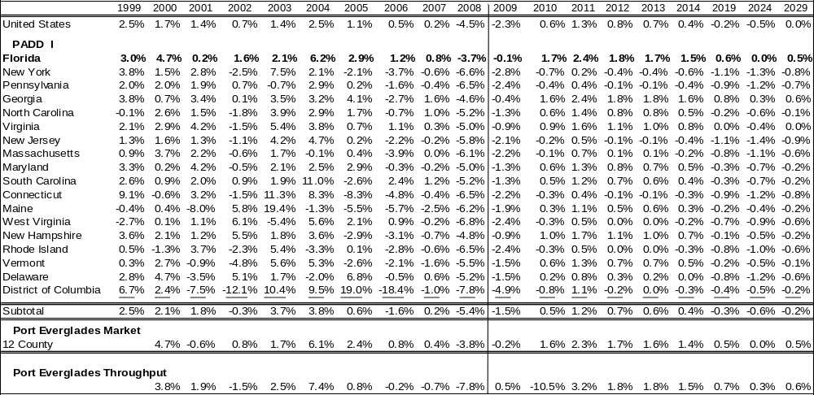
Total US light product demand will remain essentially flat between 2008 and 2029 with a slight rise from 2010 to 2017, then a slight decline through the end of the forecast period. PADD I light product demand will shrink from over 5.1 million B/D for the 2009 projection to just over 5.0 million B/D by 2029.

Figure 2.5-5
Twelve-County Market Served by Port Everglades*

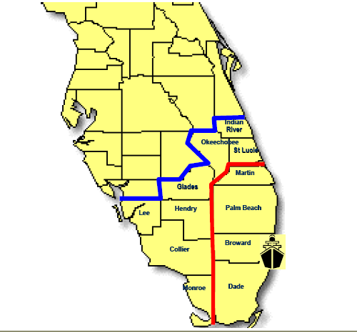

*The Port’s immediate 4-county market comprises Miami-Dade, Broward, Palm Beach, and Martin Counties, as outlined in red. The 8-county secondary market includes Collier, Glades, Hendry, Indian River, Lee, Monroe, Okeechobee, and St. Lucie Counties
Florida also leads all states in PADD I in terms of light product demand volume. Expected to top 798,000 B/D in 2009, Florida’s light product demand will top 931,000 B/D by 2029, as shown in Table 2.5-3. The 12-county Port Everglades market will grow at a faster rate than the rest of PADD I with demand expected to be 313,000 B/D in 2009 and around 362,000 B/D by 2029.

Table 2.5-3
United States Light Product Demand
(Thousands Barrels Per Day)
Error! Not a valid link.
2.5.4 Market Assessment
Major Competitive Ports in Florida. Port Everglades competes with other ports in Florida as well as with other Gulf Coast, Eastern Seaboard, and Caribbean ports across business sectors. In the petroleum sector, only the Port of Tampa and the Port of Jacksonville currently have diversified petroleum operations on a similar scale to Port Everglades. The other ports are primarily oriented around fuel oil operations for ship bunkering or for supply to local power plants. A number of expansion projects, however, that will change the competitive landscape in the Port Everglades service area are either underway or in the planning phases. These projects are discussed in more detail later in this section.
Of the competing ports within Florida, the Port of Tampa, on the Gulf Coast, is approximately 235 miles driving distance (over 300 miles by water) from Port Everglades. Tampa clearly has a geographical advantage in terms of supply from Gulf Coast refineries; but the petroleum products must be trucked from Tampa across the state over 80 miles to penetrate the outer 12-county market served by Port Everglades.
Port Manatee is 35 miles south of the Port of Tampa and about 210 miles driving distance from Port Everglades. The receipts at this port have been primarily residual fuel oil for bunkering and for supplying the nearby FP&L power plant.
The Port of Jacksonville is approximately 320 miles north of Port Everglades along Florida’s Atlantic Coast. Jacksonville has a location advantage in terms of supplies from New York Harbor and European imports. To penetrate the outer 12-county market served by Port Everglades, however, products must be trucked over 170 miles, which is beyond the typical practical trucking range.
Port Canaveral is located approximately 170 miles north of Port Everglades and is within trucking range of counties served by the Port of Tampa, Port Everglades, and the Port of Jacksonville. It is also ideally located to serve the growing Central Florida/Orlando market. In addition to residual fuel oil, Port Canaveral currently receives small volumes of light refined products, but not enough to satisfy the demand in its surrounding area.
The Port of Miami is located approximately 35 miles south of Port Everglades. Miami’s volumes are primarily residual fuel oil for ship bunkering and power plant operations at Turkey Point, further to the south.
The Port of Palm Beach is located approximately 50 miles directly north of Port Everglades. Until recently, essentially all the volumes through the port had been residual fuel oil for power plant fuel; but a new terminal was completed in 2007 that will bring more diesel fuel into the market.
In P&G’s 2005 Petroleum Sector Strategy Study, trucking companies indicated that the typical practical range for truck deliveries is 120 to 130 miles, with runs as far as 200 miles in unusual cases. Figure 2.5-6 shows radii of 130 miles around each port indicating the areas of potential supply overlap. The more typical run distance of 120 to 130 miles is approximately half way between Tampa and Port Everglades, so there can be competition at the outer edges of each port’s delivery range. Additionally, Port Canaveral has the opportunity to compete in the ranges of the Port of Tampa, Port Everglades, and the Port of Jacksonville.

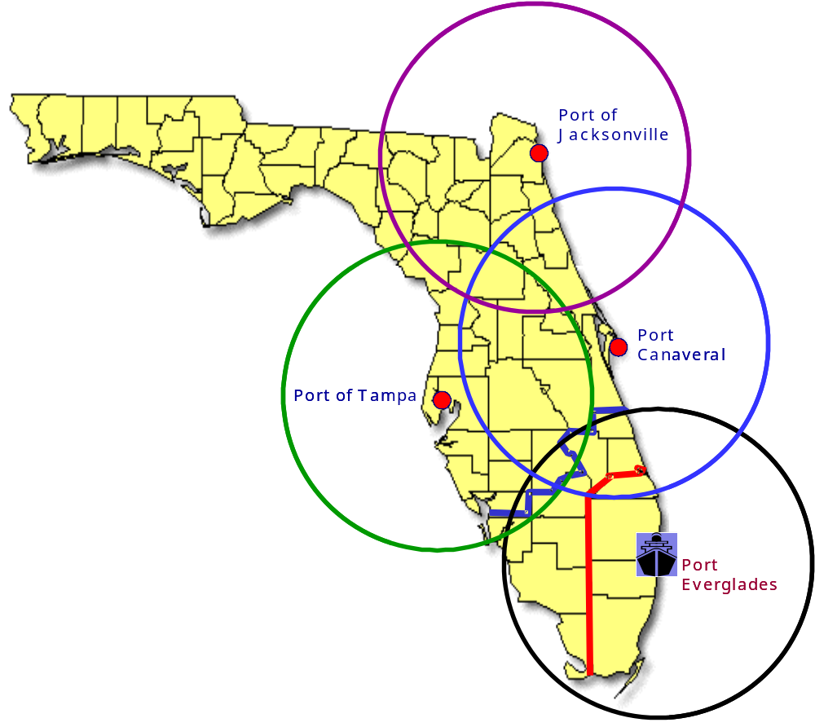
Figure 2.5-6
Competitive Port Supply Overlap

The greatest overlap is between Port Canaveral and the Port of Tampa. The Central Florida Pipeline owned by Kinder Morgan, which runs from Tampa to Orlando, gives Tampa a significant cost advantage over trucking products to the area. Port Canaveral is, however, located much closer to the Port Everglades hinterland and will be competitive in this overlapping region. Given Jacksonville’s high waterborne delivery cost from the Gulf Coast and distance from Port Everglades, it is not expected to be a significant competitor to Port Everglades.
Petroleum Throughput at Florida’s Major Ports. The petroleum throughput for the 2000-to-2006 period for the major ports, based on Waterborne Commerce data collected by the ACOE, is shown in Figure 2.5-7.
Figure 2.5-7
Total Petroleum Products Received

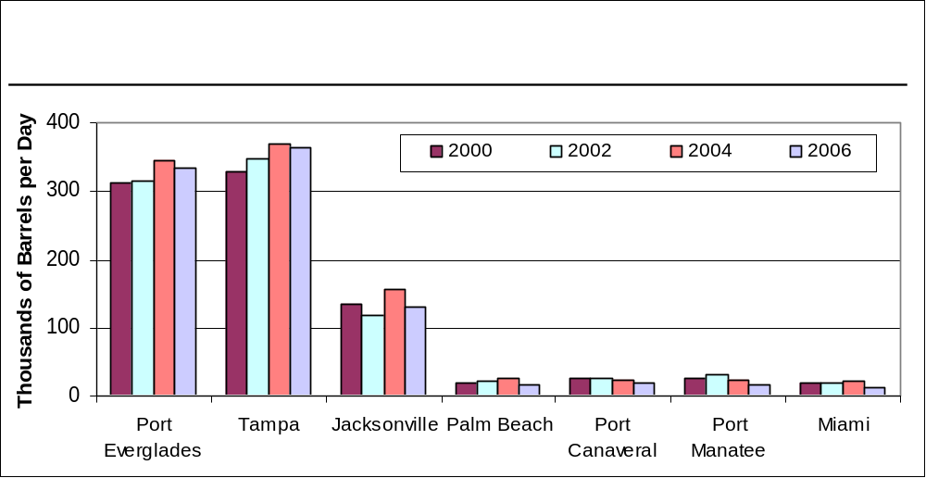
As the chart shows, the Port of Jacksonville, the Port of Tampa, and Port Everglades handle the majority of petroleum products coming into the state, with the Port of Tampa and Port Everglades being the largest by a significant margin. Receipts had been growing at most ports through 2004, but that growth slowed or declined in 2006 due to the high-price environment for transportation fuels.
Petroleum Storage Capacity at Florida’s Major Ports. Several terminal capacity expansion projects have been completed or begun in the last few years, as shown in Table 2.5-4.
Table 2.5-4
Current and Recently Completed Terminal Expansions

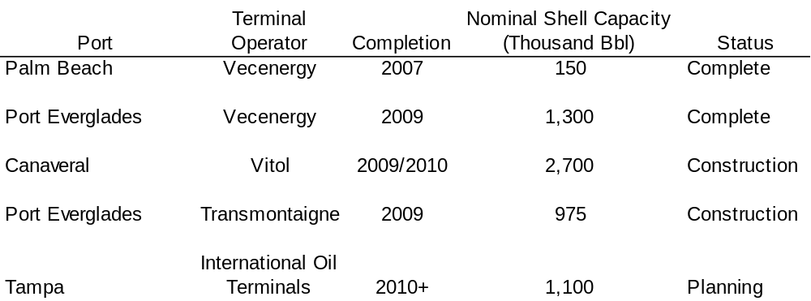

The expansions at the Port of Palm Beach and the Vecenergy terminal at Port Everglades are complete and are currently operating, while the others are due to be completed within the next year to 18 months. The addition of the above 6.23 million barrels of storage capacity represents almost a 24 percent increase over the 2005 available capacity identified in. the PGI report.
The estimated storage capacity at each port is shown in Figure 2.5-8. The capacity expansion for projects currently underway is included in the chart as a separate bar, reflecting the size of the expansion and the capacity of the terminal once the expansion is complete. As the chart shows, the Port Canaveral expansion is quite large, effectively tripling the port’s petroleum storage capacity. When these three expansion projects are completed, the storage capacity of Florida’s major ports will have been increased by 17 percent over early 2009 levels.
Figure 2.5-8
Estimated Storage Capacity

Error! Not a valid link.
The Port Everglades estimated storage capacity shown above does not include the ten out-of-service storage tanks (estimated 960,000 barrels of capacity).
In addition to these projects, several other expansions have been proposed. Since they are still early in the process, they have not been included in Figure 2.5-8, but are shown in Table 2.5-5 below. If all of these projects are completed, Florida’s ports will have experienced another 16 percent increase in capacity.

Table 2.5-5
Proposed Terminal Expansions

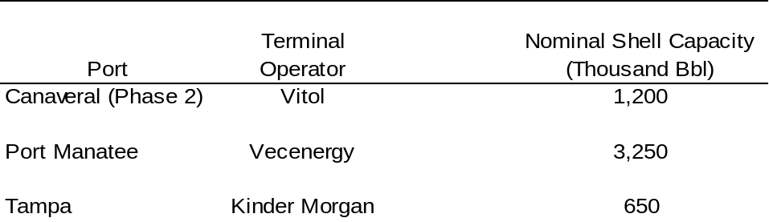

Competitor Capabilities. Details about the petroleum terminals and storage capacity of each of Port Everglades’ Florida competitors are presented below.
Port Canaveral. Port Canaveral currently has a modest amount of petroleum storage capacity. The port is well known as a large cruise port and has historically not received large amounts of light refined products. Volumes have been relatively steady over the last several years, although at levels below what they were in the early part of the decade (see Table 2.5-6). The total storage capacity at the port’s facilities is currently around 1.3 million barrels.
Table 2.5-6
Port Canaveral – Total Petroleum Products Received
(Thousand Barrels per Day)

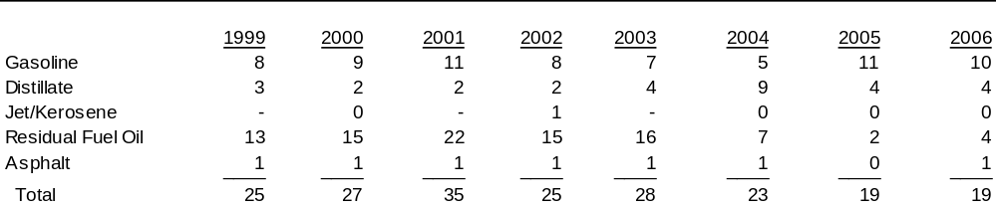
The terminal facilities at Port Canaveral are currently undergoing a large expansion. Vitol, a trading company and operator of petroleum terminals around the world, is constructing a new terminal at Port Canaveral called “Seaport Canaveral.” The terminal will initially consist of 24 tanks with a combined 2.7 million barrels of shell capacity. Completion is expected later in 2009.
Vitol is also considering a second phase of the Seaport Canaveral project. If the second phase is undertaken, it could add another 8 tanks and 1.2 million barrels of capacity to the terminal. A pipeline from the port to Orlando is also under consideration in the second phase.
It is unclear at this stage where the supply for the new terminal will originate. There has been no publicly announced leasing of any of the new capacity, although this may materialize as the project gets closer to completion. Alternatively, Vitol, in its capacity as a trading company, may purchase the fuels themselves, ship them to the terminal, and then sell them to local distributors.
Port Canaveral’s primary competitive points will likely be along the more heavily populated coastlines to the north and south, and potentially the nearby market of Orlando. Jacksonville, Port Everglades, and Tampa already serve parts of these markets, so there will likely be vigorous price competition to gain market share once the new terminal is operational.
Table 2.5-7 outlines the gasoline and diesel fuel demand that is likely to be captured by the new Seaport Canaveral terminal. The markets that are most at risk are the counties of Flagler and Volusia to the north and Indian River and St. Lucie to the south (see Figure 2.5-9). The latter two counties are within Port Everglades’ 12-county market, but are within a relatively short trucking distance from Port Canaveral. Since the delivered costs to the terminals at Port Canaveral and Port Everglades are similar (as discussed in a later section), these markets will be difficult to defend.
Table 2.5-7
Likely Service Area of the Port Canaveral Expansion,
Incremental Gasoline, and Diesel Fuel Demand
(Thousand Barrels per Day)

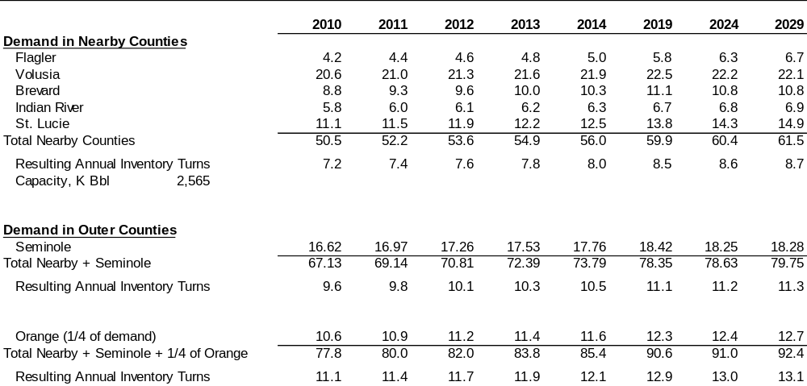
The existing terminals at Port Canaveral were already serving part of the gasoline and diesel demand in Brevard County, but not all of it. Thus, once the new terminal is operating, it will be able to meet the remaining demand within Brevard County along with the four counties mentioned above. In capturing these markets, the new terminal will have an inventory turn rate of about 7.2 turns per year, rising to 8.7 turns per year by 2029 as demand rises from current levels in those areas.
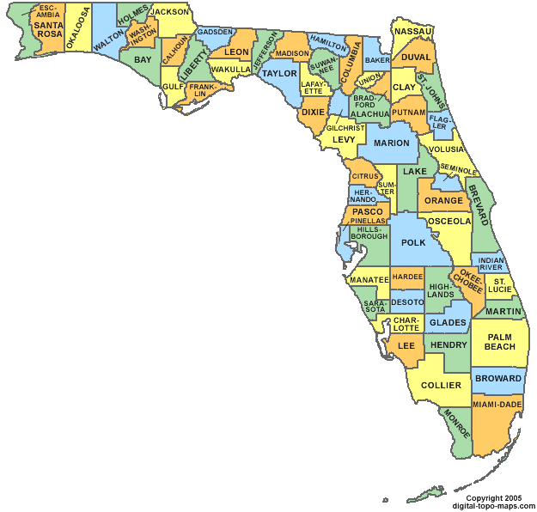
Figure 2.5-9
Counties Subject to Changed Market Capture
Seven to eight inventory turns annually is on the low end for a diversified petroleum terminal in Florida. In P&G’s 2005 Petroleum Sector report, Jacksonville was listed at 9.5 turns per year, Port Everglades had 14 turns per year, and Tampa had the highest at 17.5 turns per year. Seaport Canaveral will likely need a throughput corresponding to about 10 turns per year to achieve adequate returns. Thus, the market served by the new terminal will need to be larger than just the five nearby counties.
The next most likely region for Seaport Canaveral to serve is Seminole County. It has a relatively high demand for gasoline and diesel fuel, is well within trucking range, and has acceptable highway access. Capturing Seminole County would give the new terminal an inventory turn rate of about 9.6 turns per year in 2010, rising to 11.3 turns per year by 2029. These turn rates seem adequate and would be the most likely outcome of the change in how demand is met once the new terminal is operating.
If Port Canaveral is more aggressive in trying to take market share, it is possible that it could capture part of the Orlando market. Orlando is a large and growing area, and would be attractive to the new terminal. The Port of Tampa is, however, firmly entrenched as a supplier to this market, and has a transportation advantage with Kinder Morgan’s Central Florida Pipeline. Tampa will probably be able to defend most, if not all, of the Orange County market, and consequently Seaport Canaveral is shown capturing up to one-fourth of Orange County as a high case. If Seaport Canaveral is successful in doing this, it can achieve inventory turn rates of 11.1 turns per year in 2010 to 13.1 turns per year in 2029. At these inventory turn rates, the new terminal will be getting close to an expected capacity of 14 to 15 turns per year.
The net impact on Port Everglades from Seaport Canaveral’s expected capture of gasoline and diesel fuel demand is shown in Table 2.5-8. The demand in Indian River and St. Lucie counties can be supplied by truck from Port Canaveral itself. The new terminal’s push into Seminole and Orange counties, currently served by the Port of Tampa, will, however, likely displace some of that volume southward to compete in the southwestern part of Port Everglades’ 12-county market. As a worst case, all of the displaced volume is shown entering the Port Everglades market.

Table 2.5-8
Potential Impact on Port Everglades from the Canaveral Expansion
Gasoline and Diesel Fuel Throughput
(Thousand Barrels per Day)

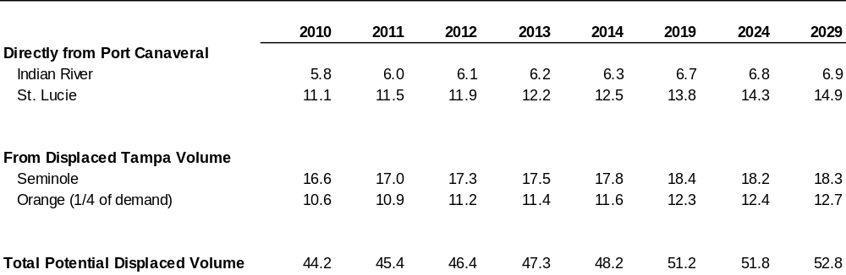
The harbor entrance channel to Port Canaveral is currently 45 feet deep. Berth depths are more limiting and are currently at 35 feet, which could limit the size of petroleum cargoes brought into the port. It is likely, however, that new berths will be constructed as part of the Seaport Canaveral project, with depths appropriate for the larger vessels. Additionally, however, Port Canaveral’s master plan indicates a current tidal restriction on movements of vessels with more than 39 feet of draft.
Port of Palm Beach. The Port of Palm Beach, just to the north of Port Everglades, primarily serves as a distribution center for cargo received by the larger ports and destined for the smaller ports in the Caribbean and Central America. In the past, the port had a small petroleum operation focused on residual fuel oil for the nearby power plant and for bunkering (see Table 2.5-9).
Table 2.5-9
Port of Palm Beach – Total Petroleum Products Received
(Thousand Barrels per Day)

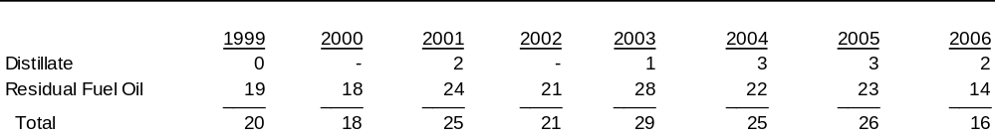

Small amounts of diesel fuel have been received in recent years, and this volume should rise modestly in the coming years due to Vecenergy’s new 150,000-barrel diesel fuel terminal. Vecenergy completed the terminal in 2007 and leased the storage to Valero. The terminal received its first cargo of diesel fuel in October 2007. Valero is expanding its refineries in Port Arthur, Texas, and St. Charles, Louisiana, to produce more fuels, and it is likely that some of this volume will supply the new Palm Beach terminal.
Waterborne delivery costs from the Port of Palm Beach are expected to be similar to those from Port Everglades, given the proximity of the two ports. Once port charges are factored in, Palm Beach should have a small advantage in delivered cost. It is expected that the diesel fuel brought into Palm Beach will satisfy local demand within the Port Everglades 12-county market, and thus will reduce Port Everglades’ throughput somewhat. Given the small size of the Palm Beach terminal, however, the impact on Port Everglades is expected to be small. Assuming annual inventory turns of 10 per year, throughput at the new Palm Beach terminal should be around 3,900 B/D.
The Port of Palm Beach faces draft limitations on vessels that may call at the port. The entrance channel is only 33 feet deep, as are the deepest berths in the port. An ACOE study is currently underway to deepen the entrance channel to 42 feet.
Port of Tampa. The Port of Tampa is the largest in Florida in terms of petroleum product volume received. It has an advantage over Port Everglades in that it is closer to the refineries on the Gulf Coast, resulting in lower transportation costs for domestically sourced fuels. Tampa also has the ability to move petroleum products to the large and growing Orlando market via the Central Florida Pipeline, which further reduces transportation costs as compared with trucking those volumes to Orlando. Volumes received by the port had been growing steadily, but declined in 2006 as a result of falling demand induced by high fuel prices (see Table 2.5-10).
Table 2.5-10
Port of Tampa – Total Petroleum Products Received
(Thousand Barrels per Day)

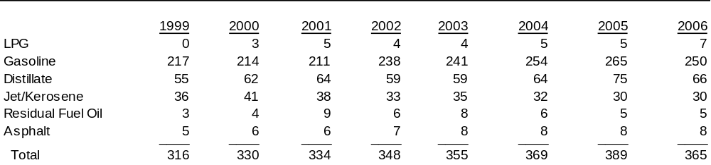
Although the Port of Tampa receives more refined products than Port Everglades, it has less storage capacity. This results in higher utilization rates (inventory turns) and more frequent refined product deliveries, which could limit Tampa’s ability to meet demand increases in its service area. The Tampa Port Authority has recognized this, noting in its 2008 Master Plan that utilization rates are nearing the maximum for unscheduled vessel arrivals.
In September 2008, the Port of Tampa announced that International Oil Terminals, an affiliate of International Oil Trading Company, would begin building a large new terminal. The new facility will have between 15 and 25 tanks, with a capacity of about 1.1 million barrels; originally expected to be operational in 2010, the terminal now appears likely to be delayed.
In addition, the Tampa Port Authority has committed to building one new dock and expanding an existing one to handle the increased product volume and vessel traffic. The new dock is expected to be able to handle vessels with 45 to 50 feet of draft. The necessary piping will also be installed to make these two docks usable by other petroleum companies operating at the port.
Additionally, Kinder Morgan is considering constructing a pipeline from its terminal at the port to Tampa International Airport. Supporting this potential project would be an expansion to its terminal storage capacity of an estimated 650,000 barrels.
The entrance channel to the Port of Tampa ranges from 43 to 45 feet deep, with an operating draft of 41 feet; with this draft, the port is able to accommodate most of the large product tankers that would be expected to make deliveries to the port.
Port Manatee. Although located just south of the Port of Tampa, Port Manatee has not typically received large volumes of light refined products. The petroleum terminal capabilities at Port Manatee are much smaller than those at Tampa and are focused on residual fuel oil (as power plant or bunker fuel), although volumes of light transportation fuels have increased in recent years (see Table 2.5-11).
Table 2.5-11
Port Manatee – Total Petroleum Products Received
(Thousand Barrels per Day)

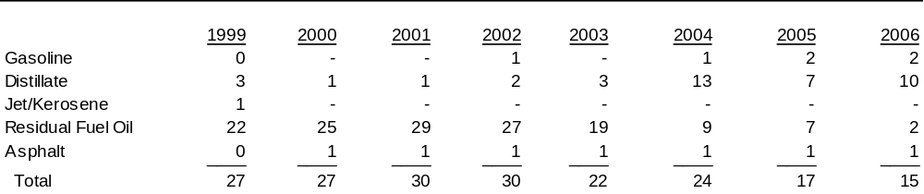
According to the port’s 2009 Master Plan, Vecenergy has purchased land adjacent to the port and plans to construct 13 tanks of 250,000 barrels each, for a total of 3.25 million barrels of capacity. If this project goes forward in its current form, it will be somewhat larger than the expansion at Port Canaveral and will likely introduce some additional competition in parts of Port Everglades’ current 12-county service area. Products expected to be stored at this terminal are gasoline, diesel fuel, and ethanol.
Draft restrictions in the main Tampa Bay entrance channel are the same for Port Manatee as for the Port of Tampa. The Port Manatee harbor channel is at 40 feet at mean low water and the petroleum berths currently also have a draft of 40 feet. The 2009 Master Plan indicates that the berths used for petroleum offloading are at high utilization rates, so the proposed Vecenergy terminal would likely require new docks if the project proceeds.
Additionally, Port Manatee is subject to special rules and limitations regarding ship arrivals due to the perpendicular orientation of the approach channel to the tidal current. Ship movements may be limited depending on the draft and LOA, including only one movement per tide of a vessel with more than 36 feet of draft.
Port of Miami. Like Port Canaveral, the Port of Miami is also well known for its cruise operations. As shown in Table 2.5-12, prior to 2003, nearly all the petroleum volume that the port received was residual fuel oil, but recently this volume has also included more diesel fuel. Only minor impacts on Port Everglades’ volumes are expected, if any.
Table 2.5-12
Port of Miami – Total Petroleum Products Received
(Thousand Barrels per Day)

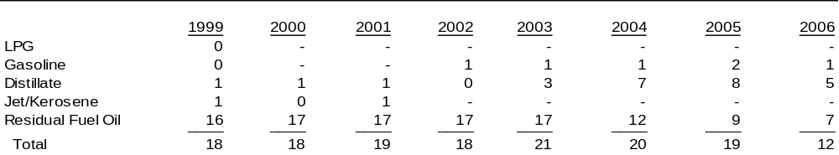

Port of Jacksonville. Located on Florida’s northern Atlantic coast, the Port of Jacksonville receives the third largest volume of petroleum products among Florida’s ports. Total petroleum products moved through the port fell in 2001 and 2002, but had rebounded to prior levels by 2003. Volume grew in 2004, but stalled and dropped somewhat in 2006, as the impact of high fuel prices reduced demand (see Table 2.5-13).
Table 2.5-13
Port of Jacksonville – Total Petroleum Products Received
(Thousand Barrels per Day)

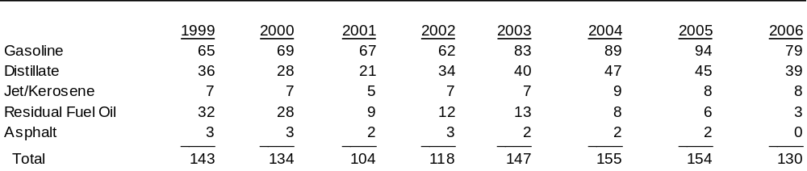

Jacksonville is located too far from Port Everglades to provide much direct competition. As the Port Canaveral expansion comes on stream, however, some of that volume will compete with markets currently served by Jacksonville. Some displaced volume from Jacksonville could push into areas currently served by Tampa, which along with the Tampa volume displaced by Port Canaveral, could be redirected to compete in parts of Port Everglades’ outer regions. The potential impact from Jacksonville is, however, expected to be minor.
New Terminals at Port Everglades. Vecenergy recently completed construction on a new petroleum terminal at Port Everglades. The facility is quite large, with 1.3 million barrels of storage, increasing the Port’s capacity by 15 percent to a total of 9.8 million barrels. The terminal is intended to receive typical fuels such as gasoline, jet fuel, and diesel fuel, but will also be able to store alternative fuels like ethanol and biodiesel.
The new terminal opened in February 2009, with the capacity having been leased to Valero. Two of Valero’s Gulf Coast refineries (Port Arthur, Texas, and St. Charles, Louisiana) are undergoing expansions, and some of the production from those refineries may be sent to this terminal.
Additionally, Transmontaigne is adding 975,000 barrels of new storage at its Port Everglades terminal facilities. Both light products and residual fuel oil are expected to be stored in the new tanks. Construction is expected to be completed in the second half of 2009.
As noted earlier, an out-of-service terminal at Port Everglades with ten tanks has an estimated 960,000 barrels of capacity. This terminal is being evaluated for re-activation. Due to its uncertain status, this capacity has not been included in the storage capacity summary.
Redevelopment of the BORCO Terminal. The BORCO terminal was originally associated with a refinery at Freeport on Grand Bahama Island. The refinery was shut down in 1985, but the terminal has continued to operate under several different owners. It is a very large terminal, having nearly 20 million barrels of storage for crude oil and both light and heavy refined products.
In April 2008, First Reserve Corporation and Vopak jointly purchased the facility. First Reserve is a private equity firm specializing in the energy industry, and Vopak is a Dutch company that is reportedly the world’s largest independent tank terminal operator.
Under the previous ownership, many of the storage tanks had become unfit for use and the available storage was reduced to about 14 million barrels. First Reserve and Vopak plan to repair or replace these tanks to bring the terminal back to its original capacity of 20 million barrels by the end of 2009. The terminal will also undergo a name change to Vopak Terminal Bahamas.
At the time of the purchase, most of the available storage was in either crude or fuel oil service, with no tanks dedicated to clean products. It is possible, however, that some of the refurbished capacity will go into clean product service. First Reserve has indicated that no decision has been made yet, and that it will depend on the market demand for clean product storage capacity. First Reserve has also indicated that it plans to further expand the terminal’s capacity in the future to 25-30 million barrels.
Part of the strategy for the acquisition of the terminal was to provide a facility that refiners or crude oil producers could use to access the US market. Because of the terminal’s deep berths, large ships unable to enter many US ports would be able to transport crude oil or refined products from distant origins to the Vopak Bahamas terminal for later distribution to one or more U. S. ports on smaller vessels, thus improving the economies of scale on the longer voyage.
Current expectations are that the flows of clean products from the Middle East and the Far East to the US will be small, given the reduction in US product demand and the availability of imports from closer regions. Market price volatility will sometimes create opportunities for those cargoes to be placed into the US, but those flows are not expected to become routine.
US Gulf Coast Refinery Expansions. Over the last several years, many refiners on the US Gulf Coast (PADD III) announced major expansion projects. Although some of those projects have since been cancelled or postponed, many are still progressing. Table 2.5-14 shows the larger expansions that are expected to be completed and that might impact the supply of refined products to Florida. The table also includes the anticipated start-up year and incremental production capacity of light products.
Because the demand for refined products has been reduced in the same time frame that new refining capacity is expected to be completed, U. S. refiners are expected to initially operate at a lower overall utilization rate. The numbers in Table 2.5-14 represent the production capacity of these new projects, which will not necessarily be fully utilized in the near term.
Table 2.5-14
US Gulf Coast Major Refinery Projects
(Thousand Barrels per Day)

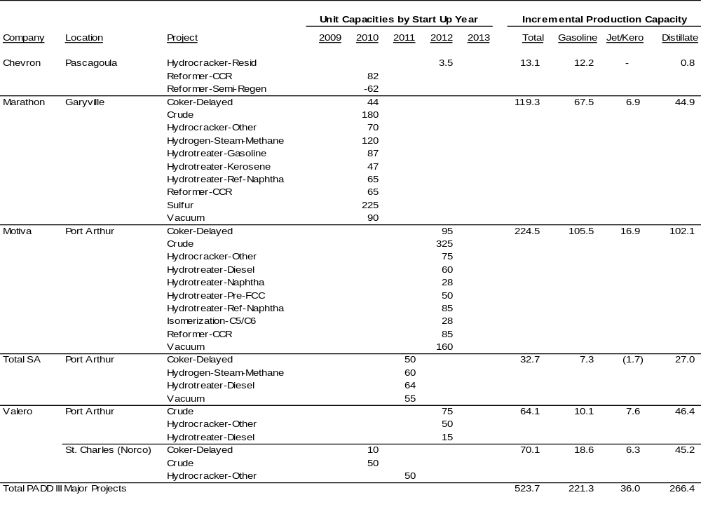

The following paragraphs describe each of the major expansions in more detail.
Chevron (Pascagoula, MS). Chevron has announced plans to both add capacity and upgrade their existing reformer technology through the construction of a new larger Continuous Catalyst Regeneration (CCR) reforming unit at their Pascagoula, Mississippi, refinery. Several additional small projects will be undertaken in support of improving gasoline yield. The CCR project has a startup date of 2010.
It is estimated that approximately 20,000 B/D of increased reforming capacity will be provided by the project in the form of a new 82,000 B/D CCR reforming unit and the shutdown of a 62,000 B/D older, less efficient semi-regeneration reforming unit. The project is expected to allow an increase of approximately 12,000 B/D gasoline production capacity. Chevron is also completing a small expansion to its residual fuel hydrocracker in 2012, which is expected to result in a small increase in diesel production.
Marathon Oil Corporation (Garyville, LA). Marathon is the fifth largest refiner in the US and has announced plans for a major expansion at its Garyville, Louisiana, refinery. The 32--year old facility is the newest grassroots refinery in the US, having been built in 1976. The Garyville expansion project will increase the refinery’s atmospheric crude capacity by 180,000 B/D to 425,000 B/D and includes many new downstream processing units. The proposed new refinery configuration and investment are designed to enable processing of heavy sour crude oils. This project continues toward a planned startup in 2010.
It is estimated that about 120,000 B/D of light product capacity will be added as a result of this project, with roughly 68,000 B/D of gasoline, 45,000 B/D of distillate, and 7,000 B/D of jet fuel.
Motiva Enterprises LLC (Port Arthur, TX). Motiva Enterprises LLC (Motiva) is the US downstream joint venture between Shell and Saudi Refining Inc. Motiva has announced plans for a major refinery expansion at its Port Arthur, Texas, refinery. The Port Arthur expansion project will increase the refinery’s atmospheric crude capacity by 325,000 B/D to 600,000 B/D, making it the largest refinery in the US. This project is projected to start up in 2012.
The Port Arthur expansion project will more than double existing crude capacity, as part of a heavy crude processing expansion. Many additional process units are also included in the expansion and are listed in Table 2.5-14. This project will result in a significant increase in gasoline (106,000 B/D), jet (17,000 B/D), and diesel (102,000 B/D) production capacity.
Additionally, Shell Trading is building at least three new Jones Act tankers to possibly increase waterborne product transfers to markets, such as Florida, that are not currently served by pipeline.
Total S.A. (Port Arthur, TX). France’s Total S.A. (Total) has announced plans to add a new 50,000 B/D delayed coker to its Port Arthur, Texas, joint refinery and petrochemical plant. Currently the Total Port Arthur refinery’s crude slate is limited to light crude oils due to its lack of vacuum residue conversion capacity. The new coker project is anticipated to start up in 2011. In addition, it is estimated that an additional 55,000 B/D of vacuum distillation capacity and 64,000 B/D of diesel hydrotreating capacities will be added to support the refinery’s goal of increased heavy crude oil processing.
The project is forecast to increase total light production by nearly 33,000 B/D, as all current residual fuel oil produced from this cracking refinery would be upgraded to light products. The project results primarily in increased distillate production capacity of 27,000 B/D, with gasoline production capability increasing by 7,300 B/D. Jet fuel production resulting from the heavier crude slate is, however, expected to be flat to slightly negative.
Valero (Port Arthur, TX). Valero approved a project to expand the crude distillation capacity of its Port Arthur, Texas, refinery by 75,000 B/D. The project also includes a 50,000-B/D vacuum gas oil (VGO) hydrocracker, which would allow the refinery to process higher volumes of heavy crude, and a small amount of diesel hydrotreating. The new units are likely to commence operation by 2012.
Production capacity from this expansion is estimated to be about 10,000 B/D of gasoline, 7,600 B/D of jet fuel, and 46,000 B/D of distillate.
Valero (St. Charles, LA). Valero also announced expansion plans at its St. Charles, Louisiana, refinery. Projects include a 50,000-B/D atmospheric crude distillation expansion, a 10,000-B/D delayed coker expansion, and the construction of a 50,000-B/D distillate hydrocracker. The start-up dates of these units are expected to be 2010 for the crude and coker expansions and 2011 for the hydrocracker.
It is estimated that this expansion would result in an increase of about 70,000 B/D of light products production capacity, with 19,000 B/D gasoline, 45,000 B/D distillate, and 6,300 B/D jet fuel.
Port Everglades Terminal Operators with US Gulf Coast Refinery Expansions. The following table shows refining companies undergoing expansions which also have terminal facilities in Florida, to which some of the incremental production might be supplied.
Table 2.5-15
Terminal Operators with US Gulf Coast Refinery Expansions

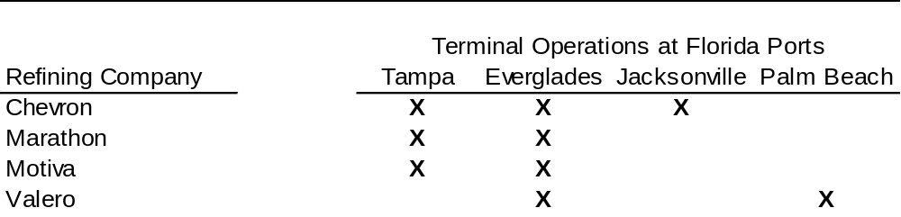

Most of these refiners also ship products on the Colonial and Plantation pipeline systems to the Eastern Seaboard and on other pipeline systems to the Midwest.
Part of the incremental production from the refinery expansions will be shipped on the pipelines due to the lower transportation costs as compared with waterborne movements. These volumes will displace some imports on the East Coast. Similarly, some of the incremental volume is likely to be shipped to Florida and will compete with import volumes there, potentially as far up the coast as Port Canaveral.
2.5.5. Petroleum Product Volume Projections
The Port Everglades petroleum throughput forecast summary is provided in Table 2.5-16 and illustrated in Figure 2.5-10. Total throughput volumes are growing from a projected 305,000 B/D in 2008 to 323,000 B/D by 2029. Gasoline throughput continues to be the leading product; however, due to a more rapid diesel demand growth, the percentage of the throughput attributed to gasoline falls slightly over the forecast period from over 53 percent of the total in 2008 to 42 percent by 2029. This section continues with more detailed discussions of each refined product.
Table 2.5-16
Port Everglades Petroleum Throughput Output
(Thousands Barrels Per Day)

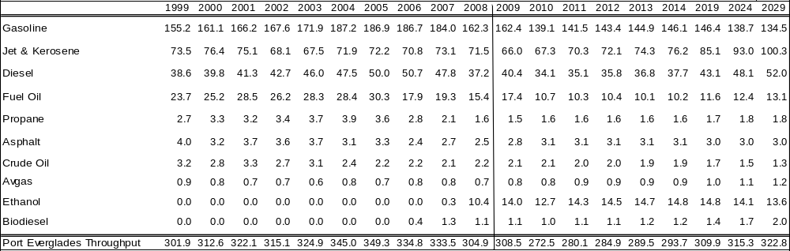

Figure 2.5-10
Port Everglades Petroleum Throughput
(Thousand Barrels per Day)

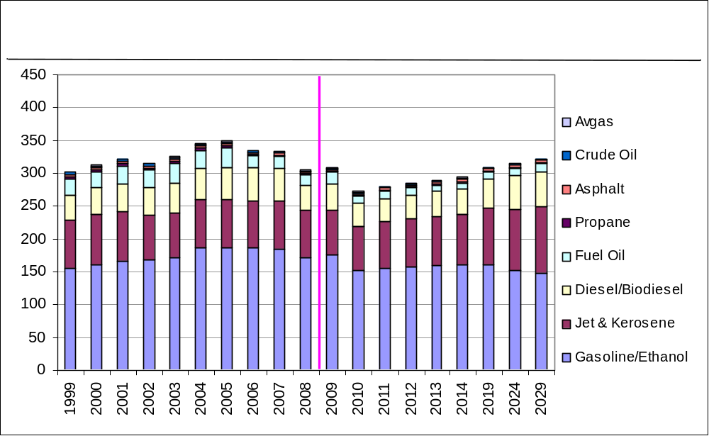
Gasoline. Gasoline projections are derived from a historical analysis of consumption on a per-capita basis, using state population data, and forecast to PADD-level demand. Gasoline growth and population growth rate projections, as well as the demand per capita are shown in Table 2.5-17 for the US, PADD I, and PADD III. For the US as a whole, per-capita demand for gasoline is at about 13.1 barrels per person of driving age per year in 2009, but then falls to 9.2 barrels per person per year by 2029. PADD I and PADD III growth rates and per-capita demand for the same periods are shown for comparison.
Table 2.5-17
Gasoline and Population Growth Rate Projections
(% Change from Previous Year)

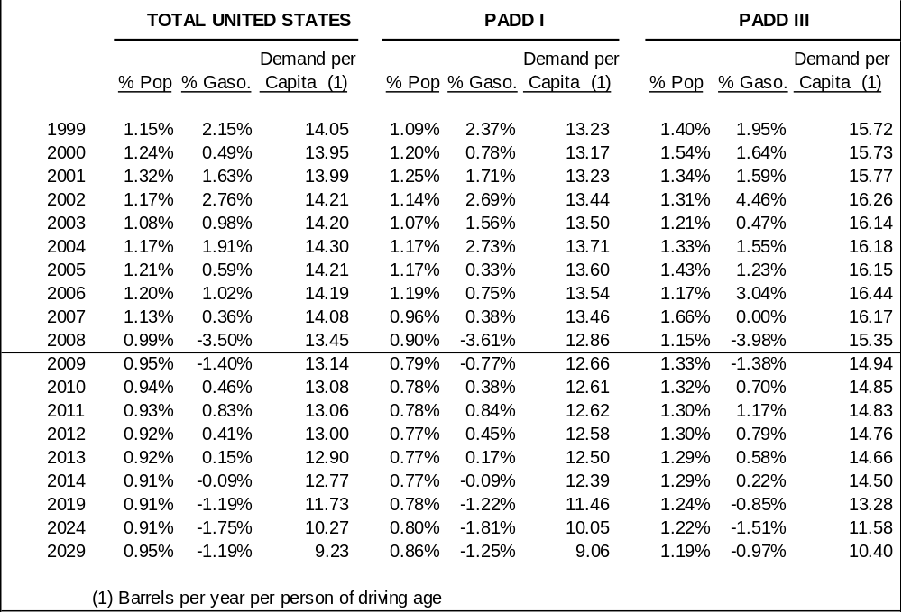

As shown in Table 2.5-18, total US demand for gasoline is expected to exceed 8.8 million B/D in 2009; Florida will lead all the states in PADD I with a gasoline demand volume of approximately 568,000 B/D. By 2029, the total US demand for gasoline is expected to decline to about 7.4 million B/D and Florida’s demand will increase only slightly, to just under 580,000 B/D.
Table 2.5-18
Gasoline Demand
(Thousand Barrels Per Day)

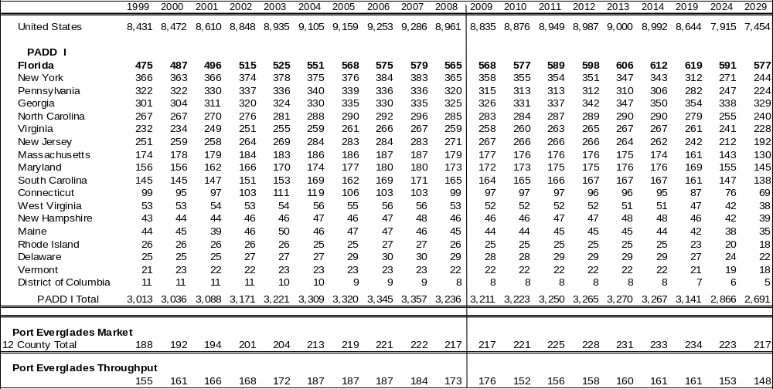
The 12-county market served by Port Everglades will consume over 217,000 B/D of gasoline in 2009 and this consumption is expected to grow 234,000 B/D by 2019 before declining to current levels by 2029. The Port Everglades throughput historically provides about 85 percent of this demand; but, with the Port Canaveral expansion project due to start up in 2009, some portion of what is traditionally Port Everglades’ market will be taken by that port. It was assumed that, beginning in 2010, Port Canaveral will service Flagler, Volusia, Brevard, Indian River, St. Lucie, and Seminole Counties as well as part of Orange County’s Orlando market (see previous Figure 2.5-9).

Diesel. Diesel projections are based on a historical consumption analysis like gasoline, placed on a per-capita basis using state population data, and forecast to PADD-level demand. Diesel growth and population growth rate projections, as well as the demand per capita are shown in Table 2.5-19 for the US, PADD I, and PADD III. For the US as a whole, per-capita demand for diesel grows from about 5.7 barrels per person of driving age per year to 6.0 barrels per person per year by 2019 and then stays constant through 2029. PADD I and PADD III growth rates and per-capita demand for the same periods are shown for comparison.
Table 2.5-19
Total Diesel and Population Growth Rate Projections
(% Change from Previous Year)

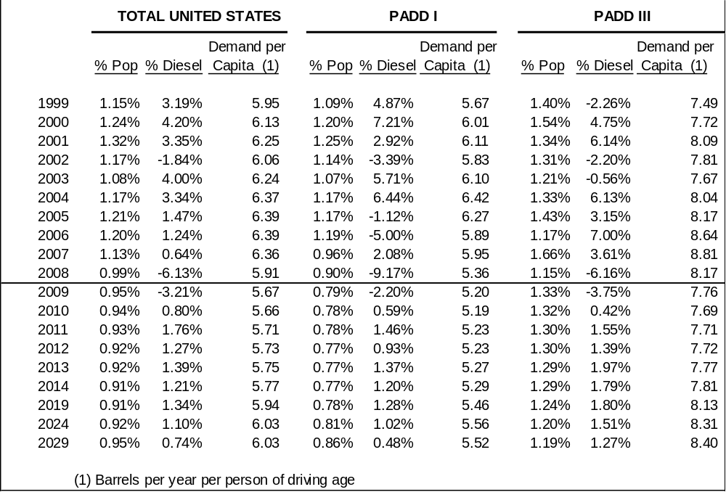

As shown in Table 2.5-20, total US demand for diesel will exceed 3.8 million B/D in 2009. Florida’s consumption will be the third highest of all states in PADD I, with demand approaching 160,000 B/D this year. Only New York and Pennsylvania will consume more diesel than Florida in PADD I. By 2019, however, Florida is expected to overtake both states as the largest diesel-consuming state in the PADD. By 2029, the total US demand for diesel will grow to almost 4.9 million B/D and Florida will consume nearly 250,000 B/D to be the nation’s third largest consumer behind Texas and California.
Table 2.5-20
Total Diesel Demand
(Thousand Barrels Per Day)

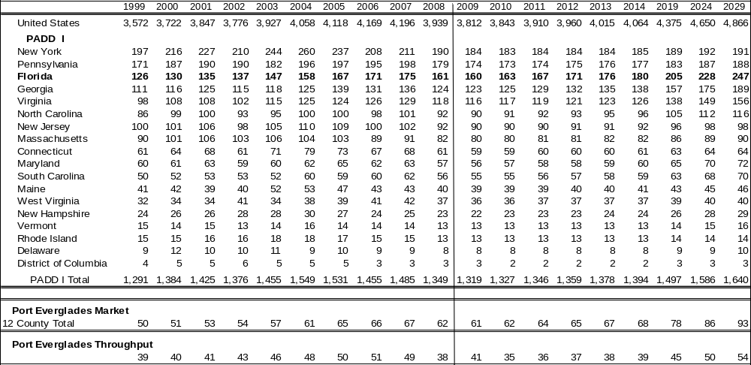

The 12-county market served by Port Everglades consumed about 62,000 B/D of diesel fuel in 2008 and this consumption is expected to grow to around 93,000 B/D by 2029. The throughput of Port Everglades historically provides about 75 percent of this demand; but, as with gasoline, the Port Canaveral expansion project due to start up in 2009 may divert some portion of what is traditionally Port Everglades’ market to that port. It was assumed that, beginning in 2010, Port Canaveral will service Flagler, Volusia, Brevard, Indian River, St. Lucie, and Seminole Counties as well as part of Orange County’s Orlando market.

Jet Fuel and Kerosene. Jet fuel and kerosene projections are based on a historical analysis of consumption, again like gasoline, placed on a per-capita basis using state population data and forecast to PADD-level demand. As previously discussed, all other states in PADD I are allocated on PADD-level FAA Airport Operations data and state-level FAA Airport Operations data. Jet fuel (excluding kerosene) growth and population growth rate projections as well as the demand per capita are shown in Table 2.5-21 for the US, PADD I, and PADD III. For the US as a whole, per-capita demand for jet fuel will increase slightly from about 2.1 barrels per person of driving age per year in 2009 to 2.3 barrels per person per year by 2019 and then level off at that rate through 2029. PADD I and PADD III growth rates and per-capita demand for the same periods are shown for comparison.
Table 2.5-21
Jet (Excluding Kerosene) and Population Growth Rate Projections
(% Change from Previous Year)

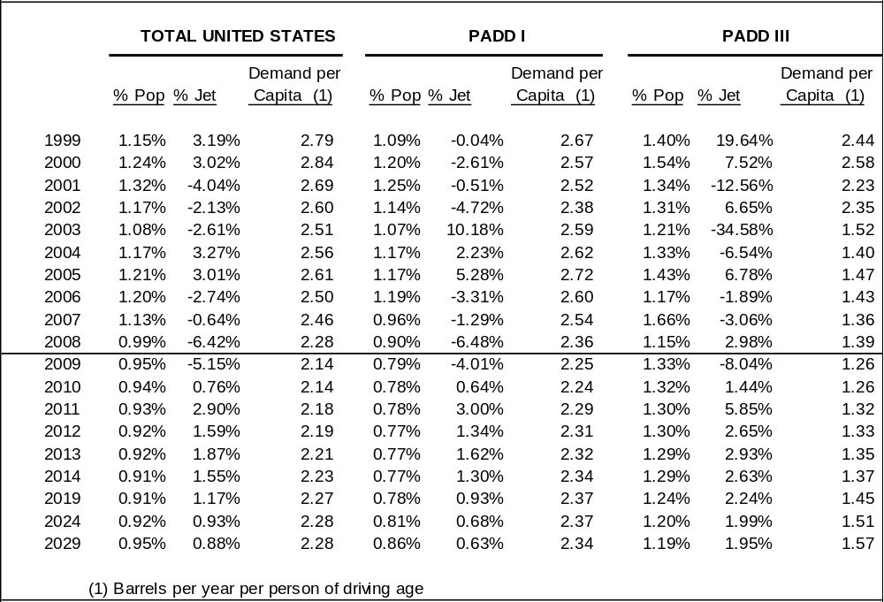

Kerosene (excluding jet) growth and population growth rate projections, as well as the demand per capita are shown in Table 2.5-22 for the US, PADD I, and PADD III. Demand for kerosene is relatively flat through the forecast period, thus growth rates in consumption fall over time as the population increases.
Table 2.5-22
Kerosene (Excluding Jet) and Population Growth Rate Projections
(% Change from Previous Year)

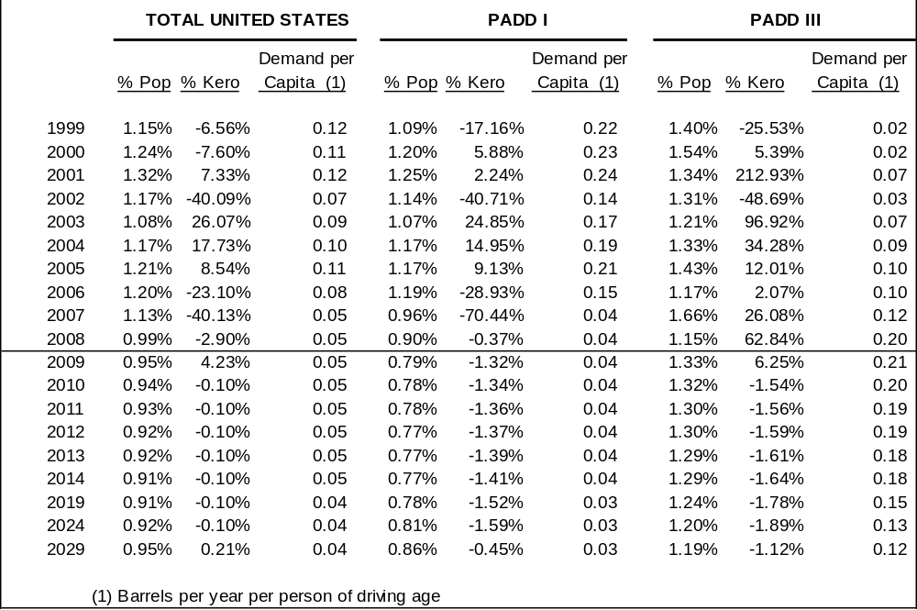

As shown in Table 2.5-23, total US demand for jet fuel and kerosene will be nearly 1.5 million B/D in 2009; Florida’s consumption will be the third highest of all states in PADD I, behind New York and Georgia, with demand volume of approximately 69,000 B/D. By 2029, however, Florida and Georgia, with a demand of 105,000 B/D each, will consume 17,000 B/D more jet fuel and kerosene than New York. By 2029, the total US demand for jet fuel and kerosene will grow to almost 1.9 million B/D.

Table 2.5-23
Jet and Kerosene Demand
(Thousand Barrels Per Day)

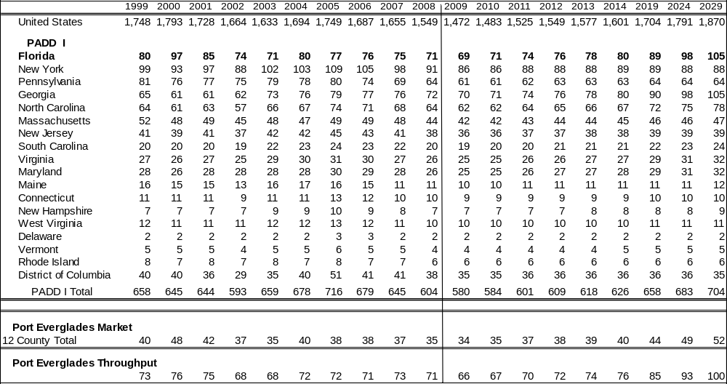
Port Everglades provides nearly 100 percent of the jet fuel demand at Fort Lauderdale/Hollywood International Airport, Miami International Airport, and West Palm Beach International Airport. To develop the forecast for this market assessment, historical Port Everglades throughput was compared with the airport operations for these three airports. A relationship was established and applied to projected state demand to forecast the Port Everglades demand. The Port Everglades demand is projected to grow at an average of around 2.0 percent annually from 2009 to 2029 and PADD I is projected to average 1.0 percent annually over the same period. The Port Everglades market will consume 34,000 B/D of jet and kerosene fuel in 2009 and this consumption will grow to over 52,000 B/D by 2029.
For the US, PADD I, and state level, jet fuel forecasts and kerosene forecasts are provided separately in Tables 2.5-24 and 2.5-25, respectively.

Table 2.5-24
Jet (Excluding Kerosene) Demand
(Thousand Barrels Per Day)

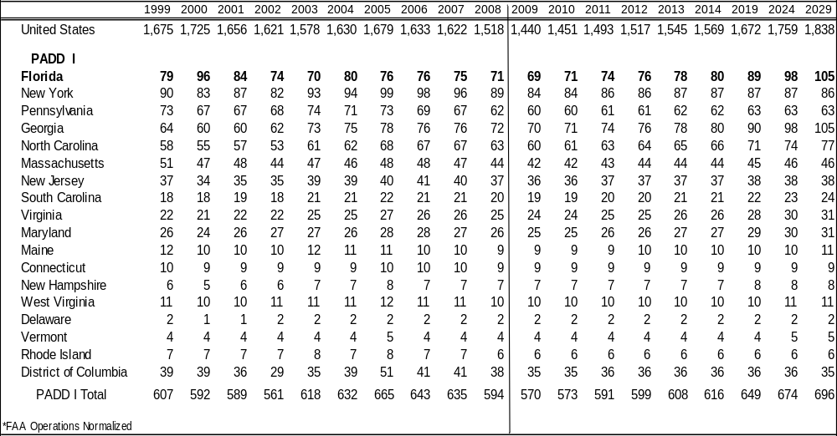

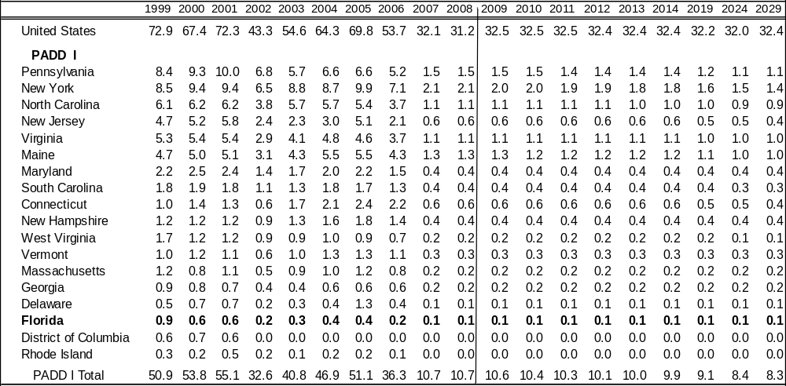
Table 2.5-25
Kerosene (Excluding Jet) Demand
(Thousand Barrels Per Day)
Fuel Oil.
Florida Power and Light. FPL operates a power-generation facility on a 94-acre site at Port Everglades. At this site, FPL has four steam boilers that are capable of firing residual fuel oil, natural gas, or a combination of both. Of the four units, two are approximately 200 megawatt (MW) in size and two are approximately 400 MW in size. Also located at the site are twelve simple-cycle gas-turbine peaking units of approximately 35 to 42 MW each, depending on the season. The 12 gas turbines are part of the FPL Gas Turbine Power Park, which also includes another 24 gas turbines at the Lauderdale Plant site. The gas turbines are capable of firing either natural gas or liquid fuel.
The trend since the early 1990s has been a steady increase in the amount of natural gas that FPL uses to provide electricity due, in part, to the introduction of highly efficient and cost-effective, combined-cycle generating units and the ready availability of natural gas. Of the FPL plants in the 12-county Port Everglades market, only the Port Everglades and Lauderdale power-generating plants are supplied with distillate and fuel oil through Port Everglades, although Lauderdale no longer uses fuel oil in normal operation. Other plants in the immediate area that consume liquid fuel include Riviera, Martin, and Turkey Point. The fuel for these plants is supplied through the Port of Palm Beach and the Port of Miami. Figure 2.5-11 shows the locations of power plants in Florida.
Figure 2.5-11
Power Plant Locations in Florida

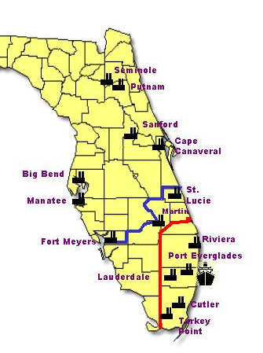

As shown in Table 2.5-26, the fuel oil requirement for FPL’s Port Everglades plant has averaged 6,400 B/D from 2007 to 2008. This usage is projected to drop off significantly to about 1,200 B/D in 2010 when Units 1 and 2 at the Port Everglades plant are scheduled to be placed in inactive reserve, which means they will be used only when necessary to meet power requirements.
Table 2.5-26
FPL Generation Capacity and Fuel Usage

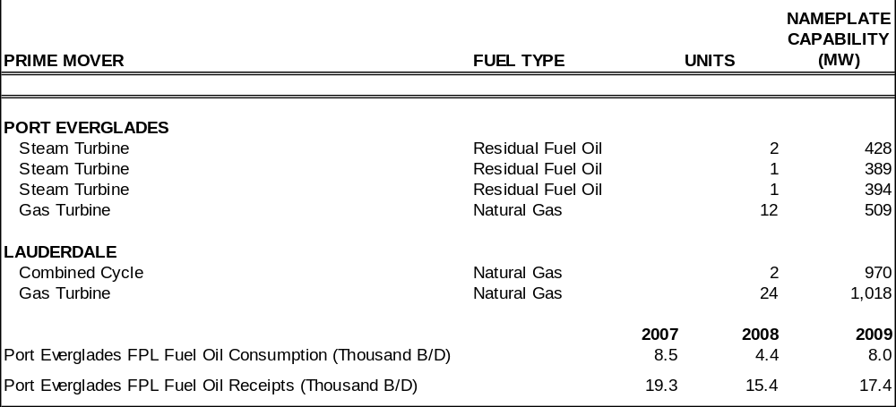
The FPL Ten Year Power Plant Site Plan shows the company’s consumption of fuel oil declining through 2014 as natural gas supply (consumption) increases to meet future growth in power requirements. The Plan also indicates that FPL will put Units 1 and 2 at Port Everglades in inactive reserve beginning in 2010, further reducing fuel oil demand in the Port Everglades market. FPL estimates that these units will be in use for approximately 3 months each year unless fuel oil prices become lower than natural gas prices, at which time the units would be required to restart.
The forecast is that FPL fuel oil requirements at Port Everglades will continue to be supplied through the Port. The demand is based on the overall net energy load for the areas served by FPL throughout the state and proportioned to FPL’s forecast energy from fuel oil. Table 2.5-27 compares the total FPL fuel oil outlook and the Port Everglades power plant outlook.

Table 2.5-27
FPL Fuel Oil Demand
(Thousand Barrels Per Day)

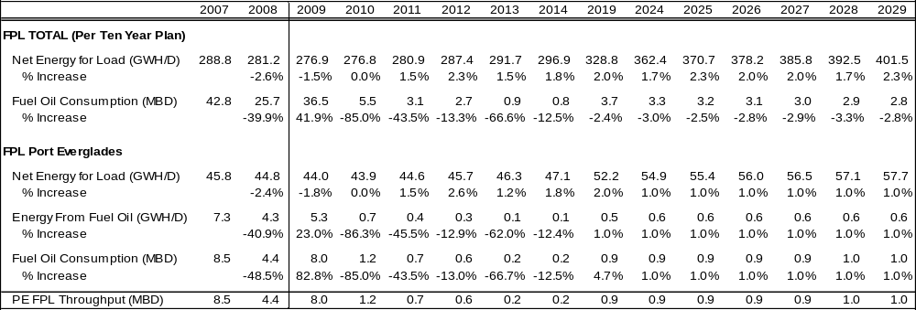

Bunker Requirements. Bunker operations are primarily served by the TransMontaigne terminal located at the Port. Using the historical bunker volumes and the number of vessels bunkered versus total vessel calls, a relationship of bunker volumes per vessel calls through time was developed. This relationship was then applied to produce the bunker forecast shown in Table 2.5-28.
Table 2.5-28
Port Everglades Fuel Oil Forecast
(Thousand Barrels Per Day)

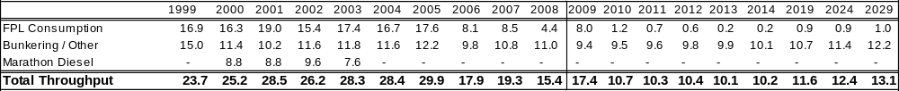
Natural Gas Impacts. Natural gas will play a significant role in FPL plans to meet its power-generation requirements for the state and the increasing availability of natural gas will exert market pressure on fuel oil requirements as mentioned above. Natural gas demand in Florida is growing rapidly, driven primarily by planned new gas-fired generation units.
LPG. All LPG movements through Port Everglades have been propane shipments made by Dynegy; these originated at their Venice plant in South Louisiana, which was destroyed in Hurricane Katrina in 2005. Much of Dynegy’s market share has been taken by C-3, which brings their LPG in through the Port of Tampa.
The forecast for LPG at Port Everglades is based on this historical trade perspective in conjunction with the following considerations:
- Florida population growth.
- Heating degree days and temperature norms.
- Florida propane market shares.
- Historical growth rates for the Port’s propane receipts.
Analysis of historical throughput indicates that propane volumes received at the Port have declined more than 20 percent each of the past 3 years due to the problems at Dynegy’s Venice, Louisiana, plant. The forecast of future propane receipts at Port Everglades, as shown in Table 2.5-29, assumes demand follows trends for all of PADD I, declining slightly in 2009 with demand growing slowly from 2010.
Table 2.5-29
LPG Forecast
Thousand Barrels Per Day

Crude Oil. Crude oil throughput at Port Everglades is declining. Total production in Florida has dropped at a faster pace than the Port’s production, leaving the Port handling nearly 40 percent of the state’s total crude oil production. The volumes of crude are not, however, a significant factor in the Port’s total throughput projections. In terms of facility utilization and optimization, however, the declining throughput is important since volumes will become increasingly smaller, moving primarily by barge, which could reduce the operational efficiency at the Port.
Asphalt. PADD-level asphalt demand was allocated to the state level in similar fashion as gasoline and diesel. This relationship was then allocated to the Port Everglades market level based on per-capita consumption and forecast population growth. The asphalt demand in the 12-county market is somewhat limited, the volumes are small, and most of the supply originates from the US Gulf. Thus, like crude oil, future operational efficiency is more of an issue than the actual throughput volumes.
Avgas. Avgas demand in Port Everglades is a very small volume. Demand is forecast to increase about 2 percent per year, on average, from 2010 through 2029. Demand has correlated well with population growth over the past 5 years so this correlation was used to forecast future demand. In terms of impact on the Port throughput, only about 700 B/D in 2008, or 0.2 percent, of the total petroleum went through the Port and by 2029, only about 1,200 B/D are projected.
Ethanol. Florida has mandated that all gasoline in the state contain 10 percent ethanol by 2010. This requires either new tanks or tank conversions at the Port, generally from gasoline service. As it is a component of gasoline, ethanol demand growth is projected to follow that of gasoline after the phase-in period is over, with demand increasing just less than 1 percent per year thorough 2019 before declining at approximately a 0.7 percent rate per year through 2029.
The majority of the ethanol volume brought into the Port is from the Caribbean and Latin America. Ethanol production capacity in the US is expanding at a rapid pace, but producing large volumes of ethanol from corn and transporting the renewable fuel to demand centers is expected to severely challenge the US agricultural industry and fuel delivery systems. For this reason, it is anticipated that the majority of ethanol demand will continue to be supplied by foreign tankers, as can be seen in Table 2.5-65 at the end of this section.
Biodiesel. Biodiesel is being shipped into Port Everglades exclusively by Transmontaigne at this time, and is brought in to blend into the diesel pool. The Port’s throughput is currently about 2 percent of the 12-county market’s total diesel demand. It is anticipated that this amount will rise slightly to about 2.5 percent of total diesel demand by 2029 and the remainder of growth will follow diesel demand, giving it an average growth rate of about 2.8 percent per year between 2010 and 2029.
Biodiesel is currently received at the Port only by either foreign tanker or domestic barge with the majority of the volume being delivered via tanker. The biodiesel production capacity of the US has increased dramatically in the past few years, but, as with ethanol, there are many challenges to shipping biodiesel to Florida so the vessel mix is anticipated to remain relatively constant over the forecast period, as can be seen in Table 2.5-62 at the end of this section.
2.5.6 Waterborne Delivered Costs
The competitiveness of the ports to supply refined products to markets in Florida depends largely on the delivered cost of refined products into each port. Since Florida has few pipelines, waterborne transportation is required to bring refined products to the state.
Waterborne Transportation from Domestic Sources. The waterborne transportation cost to each port is composed of two pieces: the cost to deliver the product from its origin to the port (inclusive of import duties and other fees as applicable) and the charges that each port imposes on its receipts, such as wharfage, dockage, etc. A comparison of the delivered costs of gasoline to the respective port terminals is shown in Table 2.5-30 for Port Everglades and two of its primary competitors, the Port of Tampa and Port Canaveral.

Table 2.5-30
Competitive Waterborne Gasoline Transportation Cost
(Dollars per Barrel)

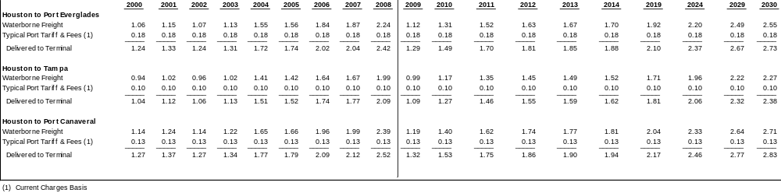

As can be seen in Table 2.5-30, the Port of Tampa has a freight advantage since it is the closest port to the Gulf Coast. Freight rates were very high in 2008, and that advantage was about 25 cents per barrel over Port Everglades. As freight rates moderate in the near term, Tampa’s advantage is expected to return to a more typical 13 to 15 cents per barrel.
Similarly, Port Canaveral has the highest waterborne freight cost since it is the furthest away from the Gulf Coast refineries. Port Everglades had a 15 cents per barrel waterborne freight advantage over Port Canaveral in 2008, which is expected to drop to 7 to 9 cents per barrel in the next few years.
Port tariffs and fees are set by each port individually and can vary considerably. Additionally, some port fees are based on a vessel’s LOA; other fees are based on gross registered tonnage; and some charges are on a per-barrel basis. Table 2.5-31 details the four major port charges (wharfage, dockage, harbormaster fees, and line-handling fees) for Florida’s major ports.
Table 2.5-31
Selected Florida Port Charges

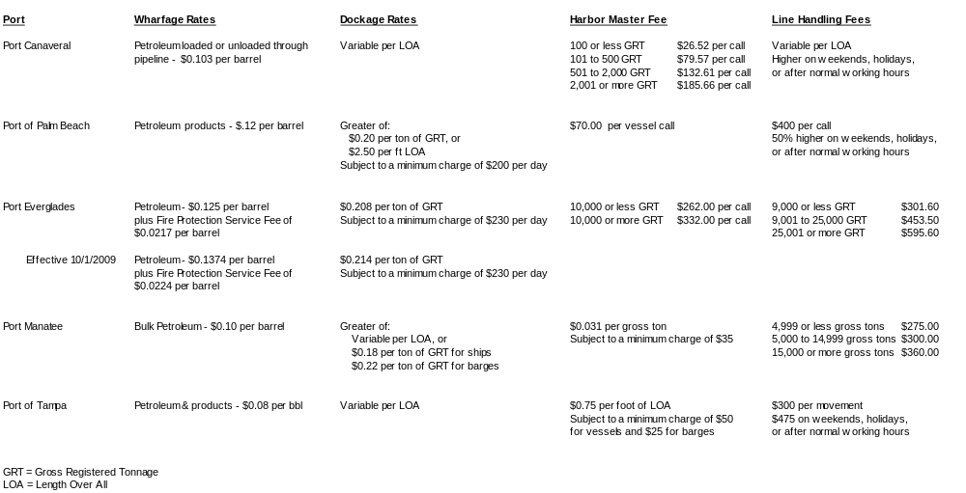
Since the charges are based on different factors, a comparison was made on a representative delivery of 250,000 barrels of gasoline on a 30,000 deadweight ton (DWT) tanker with an LOA of 650 feet. The dollar charges were then converted to a per-barrel basis and are shown in Table 2.5-32.
Table 2.5-32
2009 Competitive Port Tariffs and Fees⁽¹⁾
(Dollars per Barrel)

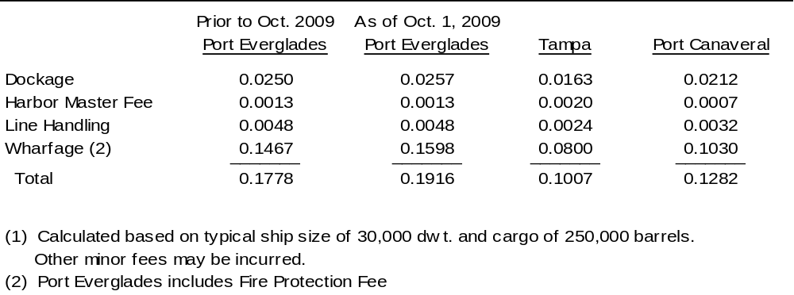

Table 2.5-31 shows that Tampa has the lowest port charges of the three ports considered. Combined with its freight advantage for deliveries from the Gulf Coast, it has the lowest total delivered cost of the three ports. The Port of Tampa enjoys a 20 to 30 cents per barrel total delivered cost advantage over both Port Everglades and Port Canaveral between 2009 and 2015.
Although Port Canaveral has a higher freight cost than Port Everglades due to its location, its port charges are lower and almost negate its freight disadvantage. Consequently, Port Canaveral has only a slightly higher delivered cost from the Gulf Coast as Port Everglades, as shown in Table 2.5-33. With the new tariff rates scheduled to take effect at Port Everglades on October 1, 2009, the Port Canaveral disadvantage is further reduced to the point that the delivered costs are almost equal.
Table 2.5-33
2009 Comparison of Waterborne and Port Costs
(Dollars per Barrel)

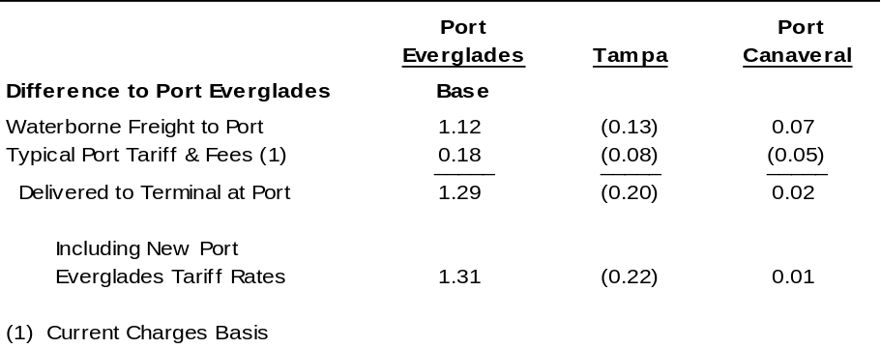

Waterborne Transportation from Foreign Sources. In addition to supplies from the U. S. Gulf Coast, Florida receives some refined products from foreign countries. Unlike domestic supply, imports are not required to be transported in Jones Act vessels and thus have somewhat lower costs. The import duties and the often greater distances traveled can, however, result in higher delivered costs. Table 2.5-34 summarizes delivered costs for gasoline (prior to blending with ethanol) from the U S Gulf Coast, Europe, and India.

Table 2.5-34
Waterborne Gasoline Delivered Cost to Port Everglades
2008 Average Prices
(Dollars per Barrel)

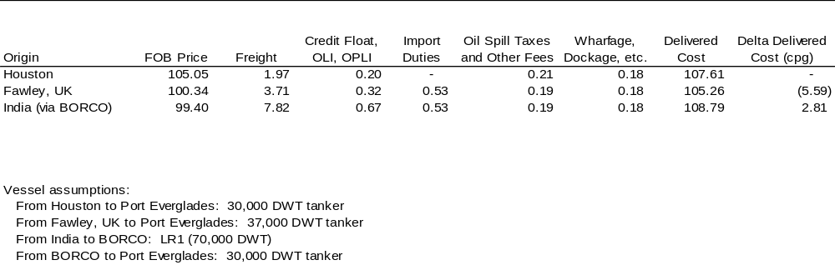

In Table 2.5-33, the foreign-sourced free on board (FOB) prices reflect the prices that could be received in alternative markets (New York and Singapore, respectively), reduced by the transportation costs back to the origin. The “Freight” column indicates the shipping cost per barrel from the origin to Port Everglades, and the next column includes the insurance charges, losses, and “float” interest, which reflects the timing differences between money paid for purchasing the products and money received for selling them. Adding the next few columns of duties and fees gives the delivered cost per barrel. The final column in the table shows the difference in delivered cost between the imported barrel and the domestic barrel in cents per gallon.
The economies of scale of shipping in larger vessels are included in the above table. A 37,000-DWT tanker, which is typical of those making voyages between Europe and the U. S. Atlantic Coast, was used in the calculations for European imports. Even with the higher freight costs and import duties, the prices in effect in 2008 resulted in a lower average delivered cost into Port Everglades than from the U. S. Gulf Coast.
Although no significant volume from India is coming to the US, it was assumed that, to overcome the longer distance and have favorable economics, the gasoline would have to be transported on a larger vessel than those running between Europe and the U. S. Accordingly, a 70,000-DWT LR1 vessel was assumed in the calculations. Because this vessel would be too large to deliver directly into Port Everglades, the cargo was assumed to be delivered to the Vopak Bahamas terminal and then loaded onto a 30,000-DWT tanker for subsequent delivery to Port Everglades. This analysis resulted in a delivered cost somewhat higher than from the U. S. Gulf Coast.
These delivered cost relationships are based on annual average prices and freight rates, which can change frequently. They are also influenced by the price of crude, demand for shipping vessels, and other factors. Table 2.5-35 shows the above calculations on both a historical and a forecast basis.
Table 2.5-35
Waterborne Gasoline Delivered Cost to Port Everglades
Differential from Houston
(Cents per Gallon)

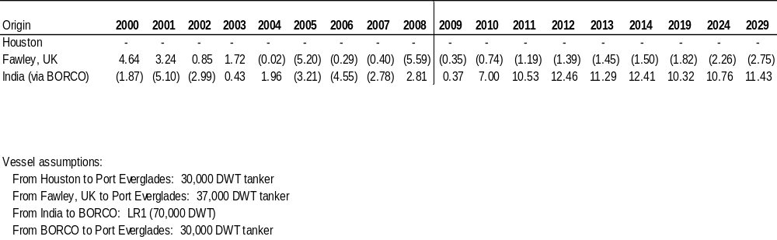
As the table indicates, importation of gasoline from Europe is expected to have favorable economics in the future. This is partially a result of the increasing use of diesel engines in passenger cars in Europe, which causes gasoline in Europe to be discounted for export. Importing gasoline from India is expected to be uneconomic on an average price basis, although there will likely be some periods when the economics are favorable.
2.5.7 Liquid Bulk Tenant/Stakeholder Interviews
Port Everglade suggested thirteen contacts to be interviewed for this market assessment. Of the thirteen contacts provided by the Port, nine agreed to be interviewed. These were Hess, Chevron, ExxonMobil, FPL, High Sierra Terminaling, Motiva, Transmontaigne North, Transmontaigne South, and Vecenergy. Their comments and views have been summarized and aggregated below.
Most of the terminal managers expect throughput through their facilities to be flat to down slightly in the next few years, with no significant change in the percentage of deliveries by ship versus by barge. As a group, they also expect the ratio of domestically sourced volume to foreign volume to be about the same.
Most also noted, however, that the Port needs to get vessels in and out more quickly than it does at present. Traffic through the Port seems to be very high at times, while at other times it appears to be very light. Increased demurrage costs have been experienced as a result of both overall port traffic and dock space congestion. Instances of competition for the same or adjacent berth space have also occurred, with non-petroleum vessels sometimes receiving prioritization over petroleum deliveries.
For the most part, product movement out of the terminals by truck functions well, although the locations of certain exit gates can cause traffic congestion at times. There is also some concern about the location of a new security gate and how it will impact access to the terminals.
Most of the terminal managers agreed that there is a trend or preference for bringing in larger vessels to reduce the transportation cost per barrel and to maximize the product delivered per vessel call. In addition to impacting current draft and beam constraints, this has also resulted in the need for loading arms with a larger operating envelope (higher reach). Real market opportunities have reportedly been available, but have been passed up due to these infrastructure issues.
Finally, supplying gasoline during the approach of a hurricane was identified as being a more complex problem now that ethanol is required in gasoline in Florida. Prior to the requirement, gasoline deliveries had to get into the port and then be trucked to service stations. Now, both ethanol and CBOB (suboctane blendstock that will meet finished gasoline specifications when blended with 10 percent ethanol) shipments must be brought into port, blended appropriately, and distributed. This will result in increased vessel traffic and increase the likelihood of mismatches between the amount of ethanol needed and the amount on hand.
2.5.8 Forecast Vessel Calls on Port Everglades
A variety of US and foreign-owned vessels ranging in size will continue to call at Port Everglades through 2029. These vessels will consist of ocean-going tankers and ocean-going barges (integrated tug-barges (ITB)). The US-owned vessels are subject to the Jones Act requirements. This section summarizes the types of vessels and their size ranges, and projects the expected number of annual future vessel calls from 2009 through 2029.
To establish the basis of vessel calls for facility planning purposes over the forecast period, it is projected that the size characteristics of the four main vessel groups -- i.e., foreign tankers, US Jones Act tankers, petroleum barges, and LPG barges -- will remain largely similar to those of the present fleet of vessels calling at Port Everglades between 2000 and 2008. Nevertheless, after discussions with several of the terminal operators, it was determined that an increase in the average size of foreign tankers is expected in the coming years. Interest was expressed in bringing in larger tankers, particularly for gasoline and jet fuel, to lower per barrel shipping costs.
The projections of vessel calls that follow are based on future throughput requirements. The planning basis used to project the number of vessel calls does not preclude the possibility that Port Everglades could accommodate larger cargo sizes associated with deep-draft foreign tankers that may call on the Port in the future. Foreign volumes have increased significantly from about 20 percent of the total ship volume in 2003 to over 40 percent currently, as a result of the Oil Pollution Act of 1990 (OPA 90). The Exxon Valdez oil spill eventually led to OPA 90, which requires all tank vessels trading in the US to have double hulls by 2015. OPA 90 also established phase-out dates for single-hulled vessels and 35-year age limits for double-hulled tankers. As several tankers were forced into retirement, the capacity of the US Jones Act tanker fleet has declined. Several new Jones Act tankers have now been built, however, and announced for refined product service, which is expected to eventually offset most of the declines to the Jones Act fleet due to OPA 90 regulations.
Domestic tanker calls and volumes are projected to recover through the forecast period, resulting in a slight reduction of foreign vessel calls and volumes. Products supplied by foreign sources, especially gasoline and jet fuel, are expected to be received in larger vessels to take advantage of the cost saving associated with larger tankers. To accommodate these vessels, it may be necessary to address current draft and beam width issues. The impact of potential dredging and other port/berth/terminal upgrading projects to reduce berth occupancy and shipping delays would require further study.
Tankers.
Vessel Size. The tanker fleet calling on Port Everglades will be made up of tankers mostly in the DWT size range of Handymax 30,000 to 60,000 tonnes, with a distribution of smaller and larger vessels similar to the present vessel fleet.
Product Types and Requirements. The tanker fleet summarized in Figure 2.5-11 will continue to handle the following products: asphalt, fuel oil (#6), two grades of diesel fuel (LSD and HSD), two grades of gasoline (regular and premium unleaded), jet fuel, avgas, ethanol, and biodiesel. The majority of the tankers (55 percent) will likely be used for a single type of cargo, with the remaining 45 percent likely to carry two to three different cargoes (usually diesel, gasoline, and/or jet fuel) onboard. Biofuels and black products (asphalt and fuel oil) will be shipped as a single cargo using dedicated vessels.
Future Vessel Calls. Figure 2.5-12 illustrates the projected number of tanker calls annually for the period from 1999 to 2029. The number of tanker calls will decline through 2010, before increasing at an annual average of 0.8 percent through 2020 and then, despite rising throughput, flattening out through the forecast period due to the projected size increase of the foreign vessels calling the Port. It is expected that the percentage of foreign tanker calls will decrease slightly through the forecast period, unlike the sharp increase experienced between 1999 and 2008, due to larger vessels and the number of new Jones Act tankers currently planned or being manufactured.
Figure 2.5-12
Tanker Calls at Port Everglades
(Calls per Year)

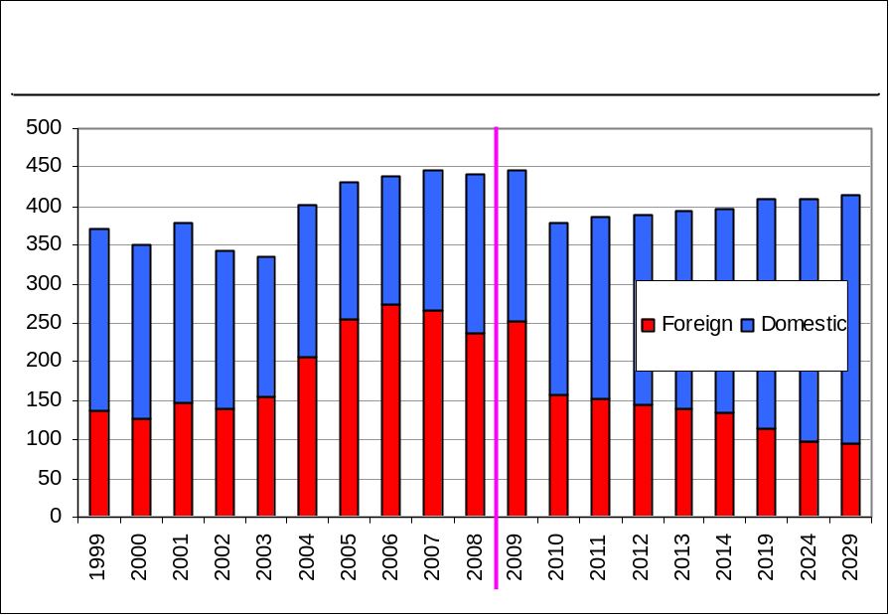
Barges. Barges are generally smaller in size, depth requirements, and unloading facilities as compared with ocean going tankers. Nevertheless, these barges are important for short-haul trips. They supply products from other US ports and also from the Bahamas.
Vessel Sizes. The barges expected to call at Port Everglades in the future should range in size from 10,000 to 320,000 barrels with an expected average size of 140,000 barrels.
Product Types and Requirements. The barge fleet is used to handle the full slate of black and clean products. Total barge calls have declined in recent years, resulting from the increased use of larger volume ocean-going barges. Beginning in 2011, barge traffic is expected to increase at an annual average rate of 1.3 percent to 2019, to meet the growth in Port throughput, before leveling off through 2029.
Future Barge Calls. Figure 2.5-14 illustrates the projected number of barge calls per year. As shown, it is expected that the number of barge calls should return to 2008 levels by 2019. The increase in barge calls is primarily driven by the growing petroleum product demand/throughput.
Figure 2.5-14
Barge Calls at Port Everglades
(Calls per Year)

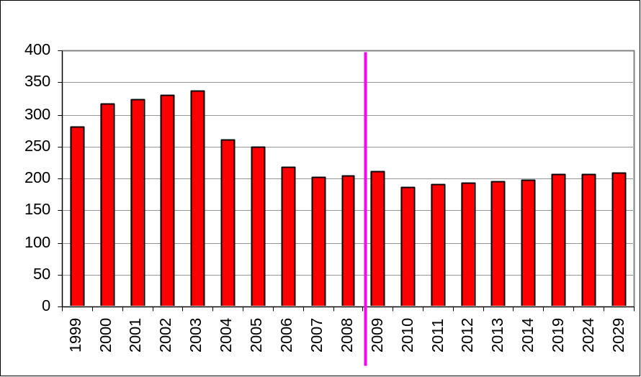

LPG Vessels. LPG demand in the Florida market, primarily for home heating and cooking, makes shipping and storage important considerations for Port Everglades. LPG barges are smaller compared with other petroleum product barges.
LPG ship calls to the Port have decreased by over 60 percent since 2005. Dynegy is the only operator bringing propane into the Port and, after Hurricane Katrina destroyed their plant in Venice, Louisiana, their supply, and therefore vessel calls, decreased significantly. Much of their market share has since been taken by C-3, through the Port of Tampa, resulting in the dramatic decrease in barge calls in recent years. Demand is forecast to resume a growth trend in 2010 through the end of the forecast period. Figure 2.5-14 illustrates the projected number of annual calls for LPG movements at the Port.

Figure 2.5-14
LPG Barge Calls at Port Everglades
(Calls per Year)
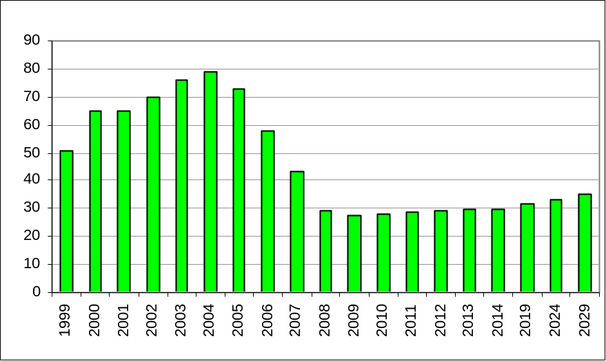

Port Everglades Vessel Call Outlook Tables. The following tables -- Tables 2.5-36 through 2.5-67 -- summarize the total vessel calls by type for the forecast period through 2029. The forecast was developed based on the throughput allocated to Port Everglades from the demand projections described earlier in this section. Based on the foreign vs. domestic trade projections, the throughput by product type is split by foreign and domestic and then projected by vessel type. Critical forecast factors in assessing the total vessels expected to call at the Port include the outright petroleum demand levels (barrels of product per day) and the average size of cargo per vessel per call. Since products are co-loaded (multiple products delivered on the same vessel), the sum of all the vessel requirements for each product exceeds the total vessels that call at the Port.
PORT EVERGLADES THROUGHPUT BY VESSEL TYPE AND VOLUME PER CALL
Table 2.5-36
Port Everglades Throughput by Vessel Type
(Thousand Barrels per Day)

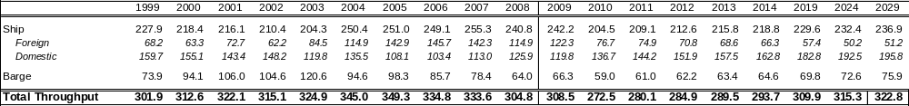

Table 2.5-37
Port Everglades Average Volume per Call
(Thousand Barrels per Call)

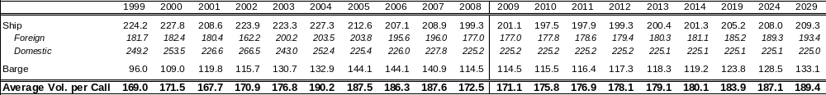

GASOLINE THROUGHPUT BY VESSEL TYPE, VESSEL CALLS BY TYPE AND
AVERAGE VOLUME PER CALL
Table 2.5-38
Gasoline (Excluding Ethanol) Throughput by Vessel Type
(Thousand Barrels per Day)

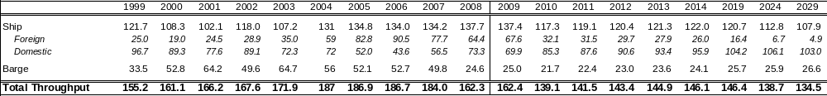

Table 2.5-39
Gasoline (Excluding Ethanol) Total Vessel Calls by Type
(Calls per Year)

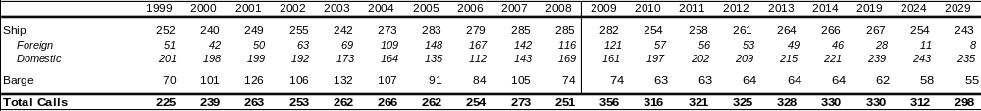

Table 2.5-40
Gasoline (Excluding Ethanol) Average Volume per Call
(Thousand Barrels per Call)

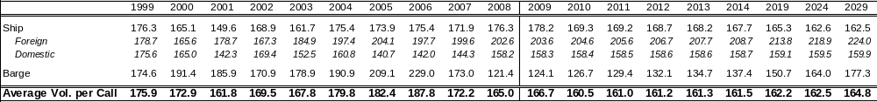

DIESEL THROUGHPUT BY VESSEL TYPE, VESSEL CALLS BY TYPE AND
AVERAGE VOLUME PER CALL
Table 2.5-41
Diesel Throughput by Vessel Type
(Thousand Barrels per Day)

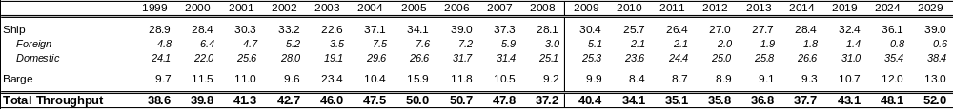

Table 2.5-42
Diesel Total Vessel Calls by Type
(Calls per Year)

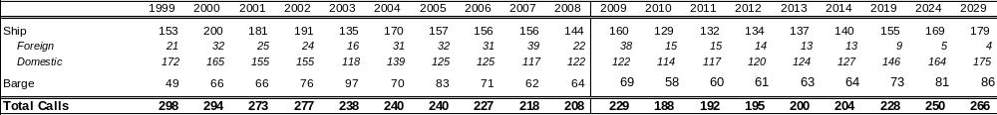

Table 2.5-43
Diesel Average Volume per Call
(Thousand Barrels per Call)

Error! Not a valid link.

JET THROUGHPUT BY VESSEL TYPE, VESSEL CALLS BY TYPE AND
AVERAGE VOLUME PER CALL
Table 2.5-44
Jet Throughput by Vessel Type
(Thousand Barrels per Day)

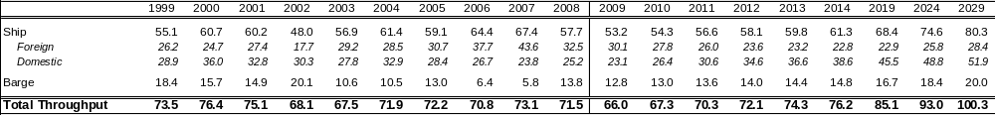

Table 2.5-45
Jet Total Vessel Calls by Type
(Calls per Year)

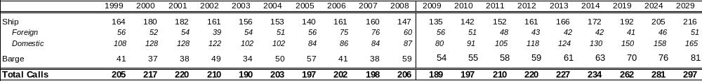

Table 2.5-46
Jet Average Volume per Call
(Thousand Barrels per Call)

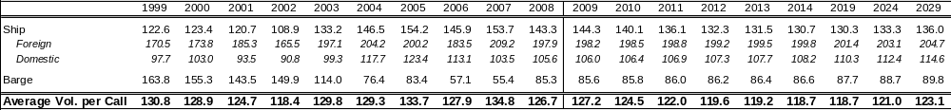

FUEL OIL THROUGHPUT BY VESSEL TYPE, VESSEL CALLS BY TYPE AND
AVERAGE VOLUME PER CALL
Table 2.5-47
Fuel Oil Throughput by Vessel Type
(Thousand Barrels per Day)

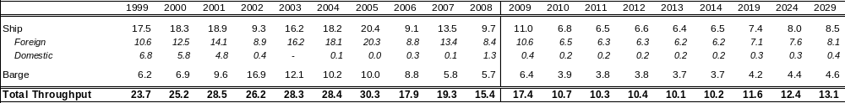

Table 2.5-48
Fuel Oil Total Vessel Calls by Type
(Calls per Year)

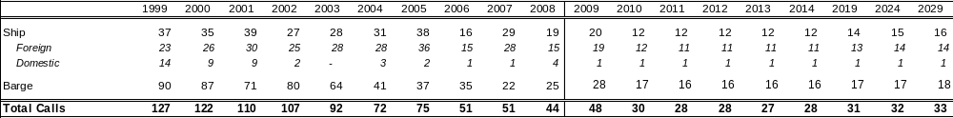

Table 2.5-49
Fuel Oil Average Volume per Call
(Thousand Barrels per Call)

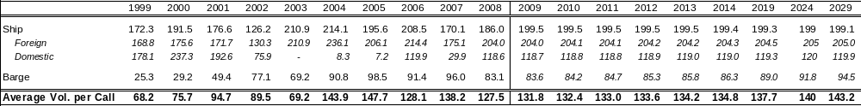

PROPANE THROUGHPUT BY VESSEL TYPE, VESSEL CALLS BY TYPE AND
AVERAGE VOLUME PER CALL

Table 2.5-50
Propane Throughput by Vessel Type
(Thousand Barrels per Day)

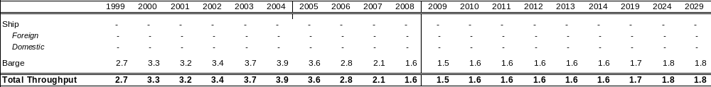

Table 2.5-51
Propane Total Vessel Calls by Type
(Calls per Year)

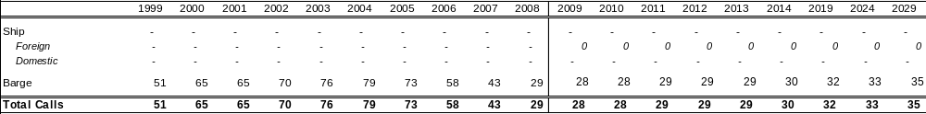

Table 2.5-52
Propane Average Volume per Call
(Thousand Barrels per Call)

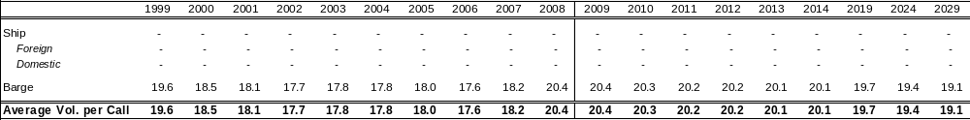

ASPHALT THROUGHPUT BY VESSEL TYPE, VESSEL CALLS BY TYPE AND
AVERAGE VOLUME PER CALL

Table 2.5-53
Asphalt Throughput by Vessel Type
(Thousand Barrels per Day)

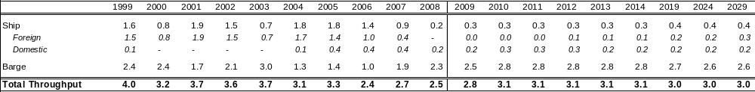
Table 2.5-54
Asphalt Total Vessel Calls by Type
(Calls per Year)

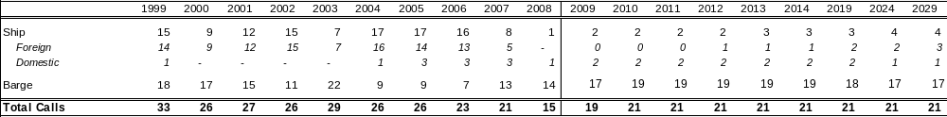
Table 2.5-55
Asphalt Average Volume per Call
(Thousand Barrels per Call)

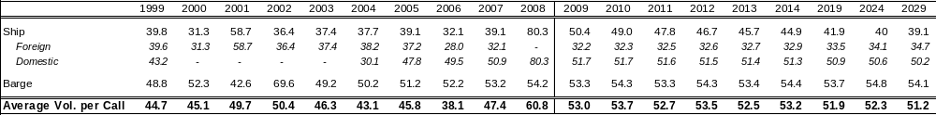

CRUDE THROUGHPUT BY VESSEL TYPE, VESSEL CALLS BY TYPE AND
AVERAGE VOLUME PER CALL

Table 2.5-56
Crude Throughput by Vessel Type
(Thousand Barrels per Day)

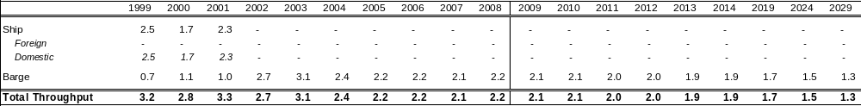
Table 2.5-57
Crude Total Vessel Calls by Type
(Calls per Year)

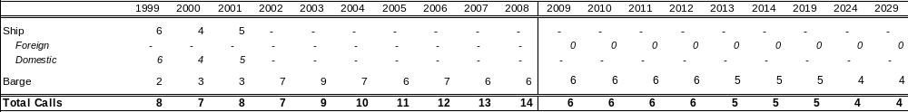
Table 2.5-58
Crude Average Volume per Call
(Thousand Barrels per Call)

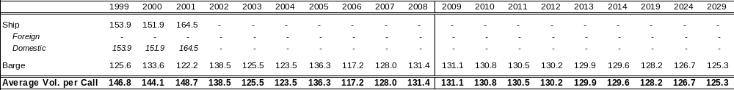

AVGAS THROUGHPUT BY VESSEL TYPE, VESSEL CALLS BY TYPE AND
AVERAGE VOLUME PER CALL

Table 2.5-59
Avgas Throughput by Vessel Type
(Thousand Barrels per Day)

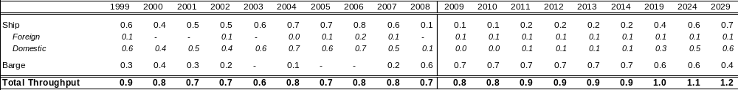

Table 2.5-60
Avgas Total Vessel Calls by Type
(Calls per Year)

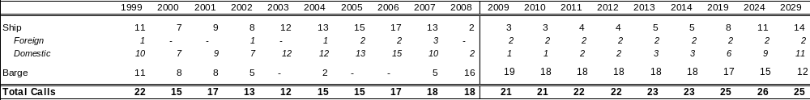
Table 2.5-61
Avgas Average Volume per Call
(Thousand Barrels per Call)

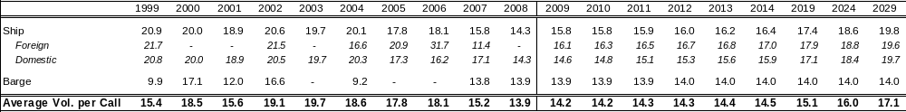

BIODIESEL THROUGHPUT BY VESSEL TYPE, VESSEL CALLS BY TYPE AND
AVERAGE VOLUME PER CALL

Table 2.5-62
Biodiesel Throughput by Vessel Type
(Thousand Barrels per Day)

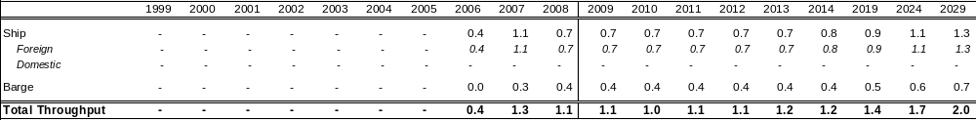
Table 2.5-63
Biodiesel Total Vessel Calls by Type
(Calls per Year)

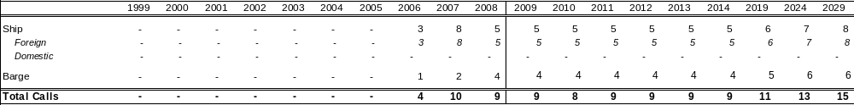
Table 2.5-64
Biodiesel Average Volume per Call
(Thousand Barrels per Call)

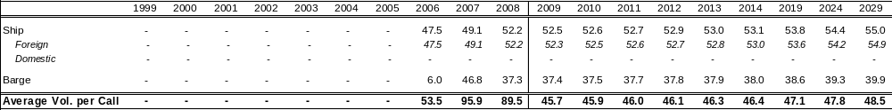
ETHANOL THROUGHPUT BY VESSEL TYPE, VESSEL CALLS BY TYPE AND
AVERAGE VOLUME PER CALL

Table 2.5-65
Ethanol Throughput by Vessel Type
(Thousand Barrels per Day)

Error! Not a valid link.

Table 2.5-66
Ethanol Total Vessel Calls by Type
(Calls per Year)

Error! Not a valid link.
Table 2.5-67
Ethanol Average Volume per Call
(Thousand Barrels per Call)

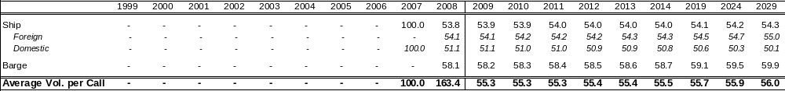

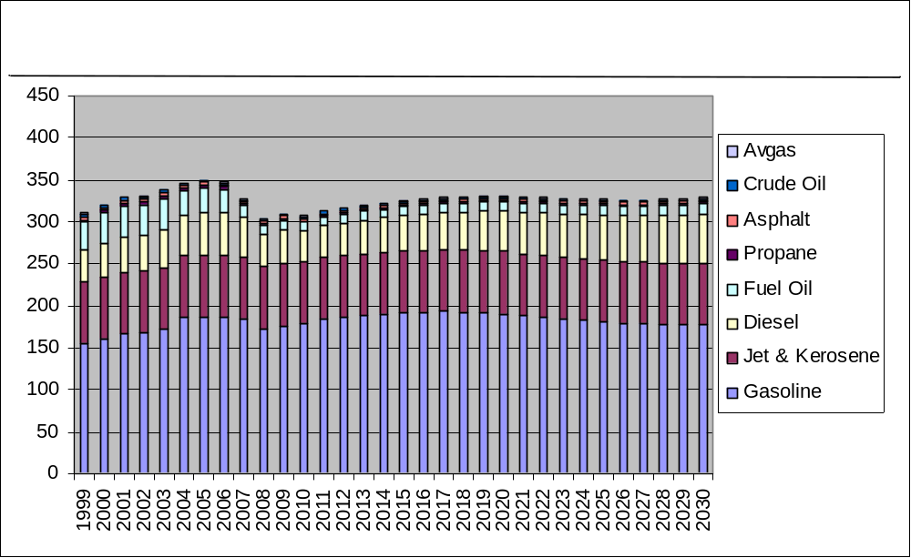

The US Department of Energy divides the country into five Petroleum Administration for Defense Districts (PADDs) for planning purposes. Florida, along with seventeen other East Coast states, is part of PADD I.
State Energy Data System, data from the Energy Information Administration
International Convention for the Prevention of Pollution from Ships
The Colonial Pipeline Company operates a 5,000-mile interstate common carrier pipeline for petroleum products. The pipeline system originates from refineries in Texas, Louisiana, Mississippi, and Alabama and delivers to 267 marketing terminals in the Southern and Eastern US The Plantation Pipe Line Company operates 3,100-mile interstate common carrier pipeline, similarly to Colonial. Major terminal locations include Atlanta, Birmingham, Charlotte, Washington, DC, and other Southeast destinations.
Long/Large Range 1 Tanker - ranging from 45,000 to 79,999 deadweight tonnes.

